Interim Report (Semi-Annual – 3) to
Italian Ministry of Foreign Affairs and International Cooperation

MULTI-SECTORAL SUPPORT FOR CRISIS-AFFECTED POPULATIONS IN LIBYA

{OMISSIS}
NFI distribution by the MRRM team in {OMISSIS} © IOM, (2022).

Executing Agency | International Organization for Migration (IOM)
Project Identification | IOM Project Code: DP.2200
Grant Reference ID
Geographical Coverage | National
Beneficiaries | Migrants in Libya, Libyans (host community and IDPs), Local authorities, Civil Society Organizations
Partner(s)Partner(s) | Relevant government authorities at national and local level
Management Site | Tripoli, CO, LIBYA Tripoli, CO, LIBYA
Relevant Regional Office(s) | Cairo, RO, EGYPT
Project Period | 1 September 2020 – 28 February 2022
Reporting Period | 1 September 2021- 28 February 2022
Date of Submission | 09/05/2022
Total Confirmed Funding | 4,500,000 EUR
Total Funds Received to Date | 4,455,446.00 EUR
Total Expenditures | 4,032,390.62

Summary of Key Achievements during the Reporting Period
The project, ‘Multi-Sectoral support to Crisis-Affected Populations in Libya’ comprises of four components:
- Community Stabilization (CS)
- Direct Assistance (DA)
- Migrant Resource and Response Mechanism (MRRM)
- Capacity Building (CB)

Through the interlinkage of these components, the project aims at contributing to the resilience of crisis-affected populations, including migrants and Internally Displaced Persons (IDPs) in Libya.
During the reporting period – the final six months of the project duration – IOM made significant progress in delivering essential services to migrants and vulnerable communities contributing to the resilience of crisis-affected populations in Libya.
Under the CS component all planned activities were completed. In total, 1414 (732 men and 682 women) beneficiaries from different community groups were involved in consultation, social cohesion and capacity building activities to promote positive relationships and peaceful coexistence (Outcome 1). In addition, following the recommendations from the consultations, 13 Community Improvement Projects (CIPs) have been completed (Outcome 2).
Under the DA component, during the reporting period, IOM has assisted a total of 5,177 individual (4,144 male, 429 female and 604 children) migrants both in detention centres and urban settings with provision of NFIs. Items that were distributed and received by beneficiaries include winter and summer blankets, winter and summer clothes, mattresses, individual hygiene kits, kitchen sets, and tarpaulins.

Under the MRRM component, 15,860 migrants (10,859 men and boys and 5,001 women and girls) were reached through the various humanitarian services the unit is providing. Particularly, 5,828 migrants received various NFIs (such as hygiene kits, clothing kits, summer blankets, tarpaulins, solar lamps, kitchen sets, mattresses, sanitary pads and diapers), 1,302 migrants received food assistance, 5,114 primary health care consultations were provided, and 4,402 migrants were reached during awareness raising sessions, informing migrants about the risks of irregular migration and alternative pathways.
Under the CB component, IOM organized a two-day workshop on Disaster Risk Reduction for 14 local and national stakeholders (13 men, 1 women). The workshop drew attention to the increase in severity of natural hazards and its migration dimensions and supported the participants in strengthening preparedness capacity by including the topics of international frameworks, mitigation measures, and response and recovery mechanisms.

Progress Made towards Realizing Outcomes and Outputs

COMPONENT I: COMMUNITY STABILIZATION
Under this component, with the objective to support the stability and resilience of conflict-affected communities, IOM aims to build on the achievements of the previous MAECI project (September 2017-December 2020), which allowed IOM to establish a presence within the communities of implementation and gain the trust of both Libyan authorities and the wider community. Based on the results of the Conflict Sensitivity Assessments (CSA) carried out in project locations, activities were carefully designed and implemented in line with a “do no harm” approach and to tackle some of the main conflict issues identified in these locations.
During the reporting period, a coordination meeting was organised from 18 to 20 January 2022 in {OMISSIS} with the participation of twenty-six of IOM’s Community Stabilization field staff and engineers from {OMISSIS}, {OMISSIS}, {OMISSIS}, {OMISSIS} and {OMISSIS}. Among the objectives were to jointly review the current and past IOM activities, discuss challenges & opportunities and plan together the next phase of activities in 2022.
Topics related to technical sessions on social cohesion and community engagement, monitoring and evaluation, internal communication, teamwork, and gender awareness in the implementation of projects were also discussed during the team meeting. This included a review of community consultation and assessment mechanisms as well as strengthening linkages to other thematic areas and programmes IOM is working on.
Outcome 1: Crisis-affected communities have enhanced social cohesion and capacities to address community issues
Under this outcome, IOM worked on bringing together community groups from different ethnic and tribal backgrounds in a spirit of cooperation, and to promote positive relationships and peaceful coexistence reaching a total of 1414 (732 men and 682 women)– . During the reporting period, IOM completed several activities aimed to: a) Promote community engagement and social cohesion with community-based and peacebuilding initiatives; and b) Build capacity of local CSOs and staff to implement projects with a focus on stabilization and social cohesion.

- Promote community engagement and social cohesion with community-based and peacebuilding initiatives
Under this output, IOM targeted the area of {OMISSIS} in the {OMISSIS} region. Pre-existing tensions between the different ethnic and tribal groups in this area, and more generally in {OMISSIS} Libya, have been high since early 2019. Women, in particular, have a limited role in local decision-making and public affairs. In addition, physical and psychological impact of the conflict has been severe on women and girls because of the stress caused by the loss of lives, amongst which were sometimes family members, as well as the loss of livelihoods and shelter in some cases.
{OMISSIS} – Photo person
{OMISSIS} - Phot Person
{OMISSIS} organization was selected to facilitate a project promoting community engagement and social cohesion. Established in 1992 in {OMISSIS} and with local branches in {OMISSIS} and {OMISSIS}, {OMISSIS} has a long experience in education and capacity building activities targeting women and youth, including media and technology education, social cohesion, mediation, and facilitation. Under the guidance and technical support of IOM, {OMISSIS} implemented several activities aimed to increase social cohesion between women living in {OMISSIS} region from October 2021 to February 2022.
Seventy-five women from {OMISSIS} , {OMISSIS} and {OMISSIS} and from different tribes living in the area ({OMISSIS}, {OMISSIS} {OMISSIS}) attended a training to improve their dialogue and facilitation skills and to support local communities through establishing peace-committees in their villages with the aim to promote a culture of peace and active citizenship.
A final ceremony was conducted on February 26 to introduce the three groups to each other and start the discussion on the committee’s creation. In each group, several participating women volunteered to create a network and ensure regular exchange on their plans. The three groups agreed on the importance to share the new knowledge and skills acquired (local conflict resolution, role of women in peace and conflict, conflict resolution and mediation skills) with women that didn’t have access to the training. {OMISSIS} , a participant from {OMISSIS} said: “I think women are active members of our society and we’re often involved to solve issues in and outside our family, but unfortunately most of us feel really isolated, sitting at home alone and allowed only to meet with relatives. During the training I understand that women coming from different tribes in our area are experiencing the same condition and this immediately creates a strong bond between us. Now we just need to change our society!”
The ceremony continued with a group discussion between the women on the possibility to implement local activities and promote a culture of peace and active citizenship. {OMISSIS} a participant from {OMISSIS} said: “I think these committees should have as a first objective to create connection in our own hometown between women. We need to develop creative and interesting activities to motivate the women to listen to us and understand the importance of taking an active role in our community. We’re facing many challenges due to economic and security issues but if we can join forces to improve our life, I’m certain we’ll succeed.”
The event closed with a concert and the distribution of certificates to all participants. IOM encouraged women to exchange numbers, create a network and to update each other regularly on their plan.
{OMISSIS} organization is now analyzing the pre and post-test and the evaluation data collected during the training. In the final report, a completed analysis will be included.
Meanwhile, preparations have been made for several activities with the L {OMISSIS} Association in {OMISSIS} , {OMISSIS} and {OMISSIS} with the aim to empower youth and enhance a sense of communal responsibility and ownership. The Scouts are a well-known and well-respected national organization recognized by the Ministry of {OMISSIS} , with extensive experience in involving local youth in sports, arts and cultural activities. After several consultations with Scout groups in each location, IOM has supported the implementation of an environmental awareness and community improvement campaign in February 2022. IOM and the {OMISSIS} identified locations of broad community access (public gardens, schools, roads) that were targeted by volunteer groups with cleaning, painting, planting trees and flowers. Public sessions with community members and sessions organized in primary schools for elementary school children took place to discuss community responsibilities to care for the environment and strengthen community cohesion.
In February, several events were organised reaching more than 450 participants. In {OMISSIS}, sixty-seven youth – 13 girls and 54 boys - participants cleaned, and planted trees in one of the main streets of the city leading to the {OMISSIS} Hospital. One participant noted: “We really enjoyed it, and we received support also from people that were stuck in the traffic. Some of them joined us to clean, it was a very good example”. In {OMISSIS} , the activities took place in four public schools: {OMISSIS} , {OMISSIS} , {OMISSIS} and {OMISSIS} schools and 250 youth and students – 224 young women and 26 young men – participated. Participants cleaned, painted the outdoor spaces and planted Ficus and olive tree seeds. A session in each school was organised to explain the positive impact of conducting similar activities, the importance of collecting garbage and recycling plastic in common and private spaces and organising a student’s committee to take care of the trees. In {OMISSIS} , 154 youth (132 boys and 22 girls) were involved. Here, the {OMISSIS} prioritized peripheral locations important for the daily life of people – a market, a school and two commercial streets. The beautification process included cleaning, collecting garbage with the support of the municipality, painting sidewalks and walls and planting trees. Inhabitants were curios regarding the activities and joined activities with the {OMISSIS}.
In addition to a daily report of each activity and feedback from participants, IOM conducted a satisfaction survey with 49 participants to measure engagement during the activities and to ensure connection between participants were made. Below an overview of the results, for the completed analysis see Annex 1.
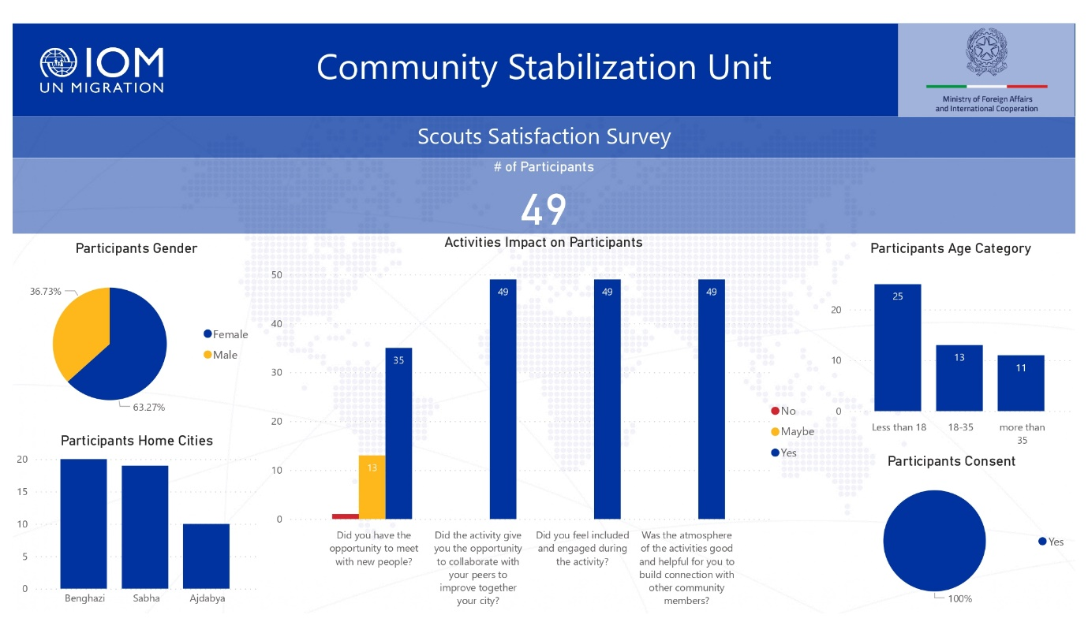

In project locations in the {OMISSIS} of Libya ({OMISSIS} and {OMISSIS}), outreach to the municipalities of {OMISSIS} and {OMISSIS} through community consultations highlighted the lack of access to information sources at primary and secondary levels of education, as well as the lack of public library facilities. IOM worked with the {OMISSIS} Department in both cities to determine appropriate schools and needs for small starter libraries. Work was conducted to agree with school heads on appropriate books lists and how to best set up small school libraries to engage students, spark their interest in reading and increase access to information; each school received a starter package of 350 books.
The second phase of the activity is being completed under the Migration Fund 2021 (project “Multi-Sectoral Support for Vulnerable Mobile Populations and Communities in Libya”) and will include a reading competition in each school, and between the schools. Apart from reading competitions with students, outreach will also be conducted with parents, specifically with the objective to emphasize their role in increasing student reading habits.

- Build capacity of local CSOs to implement projects with a focus on social cohesion and peacebuilding.
{OMISSIS}
The capacity building initiative targeting members of local Civil Society Organizations (CSOs) in {OMISSIS} , {OMISSIS} and {OMISSIS} was successfully completed. In total, 58 participants (26 women and 32 men) were involved, coming from more than 20 different grassroots organizations. Each group attended a 10-day (50 hours) professional training curriculum covering a range of topics such as the basics of project management, proposal writing, budget management, conflict sensitivity in line with the humanitarian ‘do no harm’ principle, and gender awareness. More than 300 applications were received; selection was based on a variety of factors including their area of operation, age, and gender to ensure that at least 50 per cent of participants were women.
Image 2: The final ceremony organised to distribute certificates and equipment to the CSOs training participants. © IOM, (2022).
The training course included practical exercises and the development of a project proposal. Group work between participants coming from different locations was encouraged to ensure exchange and peer to peer learning.
An internal competition was held to select the best project proposal drafted during the course. Participants also received toolkits—one tablet for each participant and one video projector for the winning proposals that will be used by the whole organization— with the aim to provide continued learning opportunities, advancing their work and helping them in their daily tasks.
Feedback from participants was extremely positive: “I appreciate this opportunity. I had the chance to learn about humanitarian topics and to gain skills that will be very useful in my work. I was happy to meet with members of other organizations and get to know about their work,” said {OMISSIS} , representing a Libyan organization from {OMISSIS} . The training’s impact was very positive with 92% of the overall participants (58 – 26 women and 32 men)- demonstrated learning progress in the post-test rates. All participants indicated that they were satisfied with the training program and learning outcomes. A completed report of the training including the programme, description, pre and post-test, evaluation training analysis and feedback from participants is available in Annex 2. Below two infographics summarizing the results of the satisfaction survey conducted after the training completion.
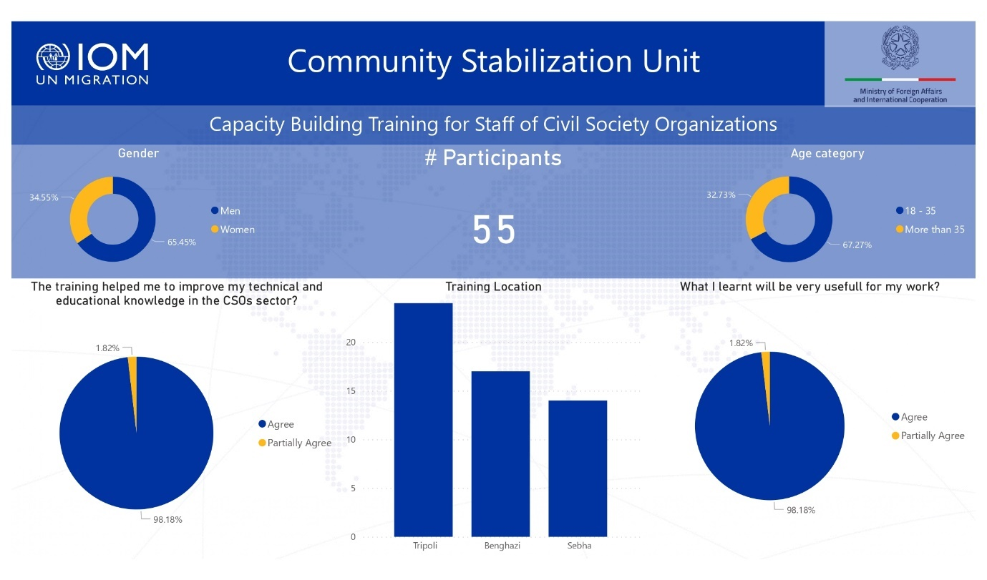

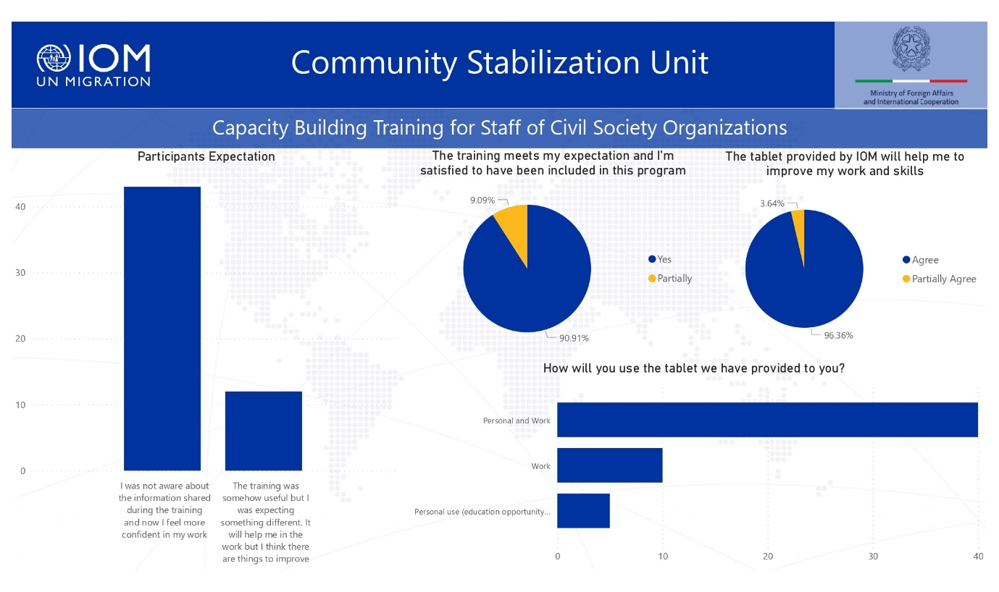

Outcome 2: Crisis-affected community members have improved access to basic services and community infrastructure
Under this outcome IOM aims to strengthen the effectiveness of local authorities by providing essential services to the community and to build trust within local communities by rehabilitating and improving essential infrastructure, such as water and sewage systems, as well as schools, hospitals, and public spaces. IOM also provided equipment, such as furniture for schools, medical equipment and generators for clinics, pumps for the water and wastewater companies, and equipment to municipal staff to improve their services. Projects are called Community Improvement Projects (CIPs) and are identified through a consultative process with local communities to engage and strengthen local capacity and foster ownership and commitment to ongoing management of rehabilitated facilities. With this outcome, IOM aims to contribute to long-term stability by reducing tension associated with inadequate access to public services, and competition over resources.
During the reporting period, 13 CIPs have completed. Below is a description of the CIPs:

{OMISSIS}
In {OMISSIS} , IOM supported {OMISSIS} School with much needed school equipment; this public primary and intermediary school is located in a peripheral area of western {OMISSIS} , also inhabited by {OMISSIS} IDPs and migrants, and enrols more than 700 students which are divided into morning and afternoon sessions. Around 10 per cent of the student body is made up of migrant children from Syria, Egypt, and Palestine. Due to the lack of essential furniture, students often have to sit in the corridors during lessons and exams, and the school cannot enrol additional students who often do not have other options since this is the only school in the area. For this reason, in coordination with the education department in {OMISSIS}, IOM handed over new furniture and equipment on the 9th of February 2022, including desks and chairs, computers for the school’s administration, printers, projectors, and air conditioners.
The handover ceremony was attended by more than 300 people including local authorities and representatives from the {OMISSIS} municipality. {OMISSIS}, the school’s principal said: “Thanks to the new furniture, we can now increase the school’s capacity with five extra classrooms to accommodate more students in the upcoming year”
In {OMISSIS} seven CIPs were completed (numbered below) following the recommendation of the community consultations with approximately 200 people in six muhallas of {OMISSIS} conducted between April to August 2021. Many residents feel that essential services provided by local government or official service providers are insufficient, including sanitation, electricity, maintenance, and water among others which decreases trust between populations and local authorities.
Provision of Generator for {OMISSIS} (1), {OMISSIS} (2) and {OMISSIS} water well (3)
These three locations have been identified as requiring a generator with a protective shade and fencing to ensure continuous access to water. {OMISSIS} and {OMISSIS} suffer from a lack of basic services such as access to water, electricity, sewage systems and health services. The situation has worsened since the crisis in 2011, with constant daily power outages for hours at a time, especially in the summer season when the electricity is available for only six hours per day. In addition to the daily challenges that people face, including the lack of access to drinkable water, there is also a risk of deterioration of the water wells since the water pumps are exposed to extreme heat and an unstable electricity source. The two generators were handed over in December 2021.
The {OMISSIS} water well (3), located near the {OMISSIS} , a remote village of approximately 5,000 inhabitants from {OMISSIS} and {OMISSIS} tribes, suffers from constant power cuts leading to deterioration of the condition of the well. This in turn has forced the community to transport water from other locations when the electricity was not available. The generator handed over in January 2022 will solve this issue and ensure regular access to water.
Provision of Generator to {OMISSIS} Physiotherapy Center (4)
On the 7th of December 2021, a generator was also installed at the {OMISSIS} Physiotherapy Centre. The centre was equipped initially by IOM in 2018 at the {OMISSIS} ({OMISSIS}) premises, a governmental organization that is dedicated to taking care of vulnerable people, especially for those with special needs and disabilities. Previously, people were travelling over 200 kilometres to reach the closest physiotherapy unit in {OMISSIS} city. Today, the centre is fully operational.
Provision of Equipment to {OMISSIS} (5), {OMISSIS} (6) Guest Houses and the Labor Office in {OMISSIS}
Guest houses (GH) are an essential facility for communities in {OMISSIS} Libya. It is the place where people meet on social occasions and also serves as accommodation for visitors and, when crisis occur, for displaced people due to natural disasters or conflict to stay. During the community consultation in {OMISSIS} people requested to provide support to certain GHs in remote areas. The first one, {OMISSIS} GH, managed by the local council, was handed over on the 6th of October 2021 with a public ceremony, attended by approximately 30 people. The GH serves a local population of approximately 4,500 people, primarily from the {OMISSIS} tribe and people from neighbouring muhallas. IOM provided furniture and equipment such as air-conditioners, an electric power generator and furniture for the main space where traditionally meetings and social gatherings take place with participants seated on rugs and traditional mattresses on the floor.
{OMISSIS} GH was handed over on October 16, 2021 to the municipality with a public event attended by 38 community members from Arab and Tebu tribes. {OMISSIS} is a remote village inhabited by 9,000 people from both tribes who experience challenges in accessing basic services. Here, the municipality have recently built a guesthouse with local crowdfunding in which inhabitants and municipality members have participated, however the building was not yet open due to lack of essential equipment. IOM subsequently provided air-conditioners, a generator and furniture.
The Labor office in {OMISSIS} is the leading government agency in the provision of public sector employment services. The stated goal of the ministry is to match labour supply and demand efficiently and effectively both in the public and private sectors, in order to accommodate both qualified local and foreign jobseekers. The ministry currently fulfils the three main functions of facilitating job placement for unemployed people: providing follow-up on the staffing of government bodies and training and capacity building. The office was unable to offer adequate services to the large community of {OMISSIS} due to the absence of appropriate furniture and IT equipment. For this reason, IOM handed over equipment such as desks and table for meeting room, laptops, printer, shelves on February 8th, 2022.
In {OMISSIS} municipality, two CIPs received equipment to the municipality and to the Guest House. {OMISSIS} is located in the {OMISSIS} - {OMISSIS} of Libya close to the Chad border, 70 km from {OMISSIS} , and is inhabited by around 4000 people mainly from {OMISSIS} tribes. It has been recently recognized as an independent municipality and lacks basic services including water, electricity, health services and paved roads.
To enhance capacity of the local administration, IOM fully outfitted the municipality building and handed over equipment including laptops, a printer and furniture such as chairs, desktops and a meeting room during a public ceremony on February 19th which was attended by more than 100 people living in the area, including local authorities’ representatives from several departments. {OMISSIS}, the mayor of {OMISSIS} , said: “Our municipality suffers from social, economic and geographical marginalization. Our office was closed due to the lack of basic equipment. We were not able to provide adequate services to the community, IOM’s intervention is essential to start our activities.”
With the same objective, the {OMISSIS} Guest House was equipped with airconditioners, power generator, a freezer, mattresses and other furniture and was handed over on December 8th, 2021. As described by an inhabitant of {OMISSIS} during the ceremony “This is the only guest house in the area, and it is serving also neighbouring muhallas. It was in very bad conditions with lack of a generator, air-conditioners, and mattresses on the floor where traditionally meetings take place; now, with the equipment provided by IOM, we’ll be able to restart public events and ceremonies”.
Through an intervention aimed to strengthen the education sector, as requested by the local community, three CIPs were completed in {OMISSIS} – the provision of equipment to two schools and to the Education Department. Many schools in {OMISSIS} were severely damaged during the armed conflict that took place in 2014, leading to substantial challenges in the education sector due to building damage and loss of critical school equipment.
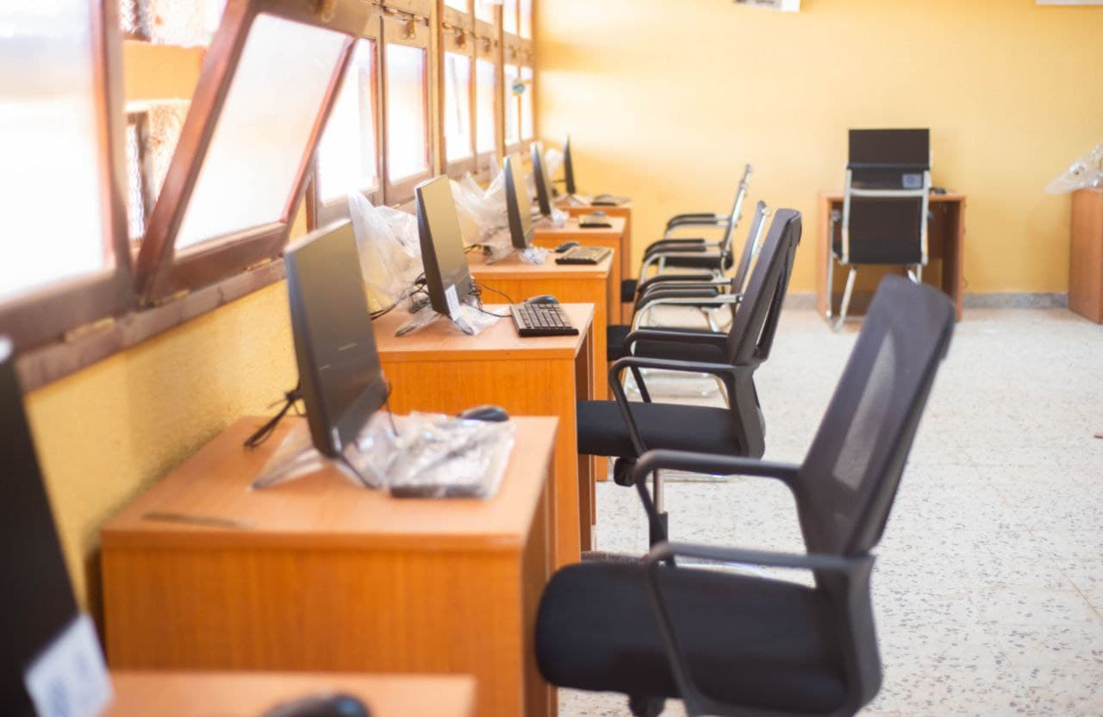
On February 26th, 2022, IOM handed over equipment to {OMISSIS} Secondary School and {OMISSIS} {OMISSIS} School during a public ceremony attended by community members, local authorities, teachers and parents. IOM provided each school with a computer laboratory and additional equipment such as conference room furniture, air conditioners, printers and photocopy machines, shelves, desks and chairs, cameras and water coolers. Lastly, IOM provided basic furniture and office equipment to the {OMISSIS} Education Office which employs about 30-40 people and has the responsibility for the curriculum and coordination of primary and secondary schools. {OMISSIS} Mayor {OMISSIS} opened the handover ceremony with a public speech: "We’re putting all of our efforts to rebuild and improve the education sector in {OMISSIS}. Schools play a key role for the future of our children and this project is a sign of hope for all the community. I’m very happy that now students have access to a computer laboratory where they can develop new skills.”
Image 5: The computer laboratory provided by IOM in Ubari Secondary School and Alwahda Alarabia School © IOM, (2022).
To ensure appropriate implementation and monitoring of infrastructure projects, IOM set up a structure of at least two local staff in each project location, typically consisting of a national operation assistant and a field engineer. As a first step, following community suggestions, a concept note was developed for each CIP to collect information on specific needs to be addressed, the rehabilitation work and equipment required, the possible impact and number of beneficiaries that would be reached. Through a public tender process, IOM assigned the grants for the CIPs to domestic vendors that were continuously monitored by field monitoring staff. At the completion of the work, IOM ensured that procured items were delivered in good condition and were functional. An event was organized to handover the project to local communities and authorities.
Furthermore, after a minimum of one month upon completion of the infrastructure/rehabilitation/ equipment grant, IOM is conducting outcome assessment visits to each site aimed at:
- Reviewing the achievements of the grant in line with intended objectives and broader outcomes, recording successes and challenges;
- Identifying urgent issues, if any, thereby enabling immediate follow-up and closing feedback loops with communities;
- Collect data to report against related to logframe indicators;

- Complying with commitments laid out under the Accountability to Affected Populations framework, including:
- Communities can expect delivery of improved assistance as organizations learn from experience and reflection.
- Communities have access to safe and responsive mechanisms to handle complaints

The monitoring visits are now ongoing, and a completed analysis will be reported in the final report.
COMPONENT II: DIRECT ASSISTANCE
During the reporting period, IOM has assisted a total of 5,177 individual migrants (4,144 male, 429 female and 604 children) both in detention centres and urban settings with the provision of Non-food Items (NFIs). Items that were distributed and received by beneficiaries include winter and summer blankets, winter and summer clothes, mattresses, individual hygiene kits, kitchen sets, and tarpaulins.

Out of the total beneficiaries assisted under direct assistance, 3,805 (2908 men, 897 women and children) migrants were reached in a total of 11 official detention centres run by {OMISSIS} whereas 1,371 migrants were reached in five urban settings whose needs were identified through referral, outreach and regular DTM team assessments in the {OMISSIS} area, {OMISSIS} city, {OMISSIS}, {OMISSIS} Embassy and {OMISSIS} shelter.

During the reporting period, the project has focused on assisting more migrants in detention and urban settings as there have been no new cases of internal displacement requiring NFI assistance. The project has reached large migrant caseloads in detention centres with provision of regular assistance such as seasonal kits and personal hygiene supplies.

The NFI kits provided were designed to meet the different needs of men, women, boys, and girls; the personal hygiene kits were composed of hygiene and sanitation as well as dignity kits for men, women, and children. In addition, IOM has considered the seasonal weather conditions and needs of migrants when procuring and distributed the NFI kits and provided winter/summer blankets and winter/summer clothing along with other items depending on the season.

Number, location, and dates of assistance to migrants are detailed below:

Area Of Distribution | Mantika | Distribution Date | Beneficiary Number | Male | Female | Children
{OMISSIS} Village | {OMISSIS} | 2/26/2022 | 261 | 137 | 87 | 37
{OMISSIS} City | {OMISSIS} | 2/25/2022 | 522 | 202 | 234 | 86
{OMISSIS} DC | {OMISSIS} | 2/24/2022 | 56 | 55 | 0 | 1
{OMISSIS} DC | {OMISSIS} | 2/23/2022 | 31 | 30 | 0 | 1
{OMISSIS} DC | {OMISSIS} | 2/23/2022 | 32 | 32 | 0 | 0
{OMISSIS} DC | {OMISSIS} | 2/16/2022 | 370 | 370 | 0 | 0
{OMISSIS} Shelter | {OMISSIS} | 2/13/2022 | 360 | 312 | 0 | 48
{OMISSIS} city | {OMISSIS} | 1/27/2022 | 191 | 83 | 66 | 42
{OMISSIS} DC | {OMISSIS} | 1/20/2022 | 650 | 634 | 0 | 16
{OMISSIS} Embassy | {OMISSIS} | 1/6/2022 | 37 | 31 | 1 | 5
{OMISSIS} DC | {OMISSIS} | 10/21/2021 | 57 | 54 | 2 | 1
{OMISSIS} DC | {OMISSIS} | 10/18/2021 | 550 | 501 | 0 | 49
{OMISSIS} DC | {OMISSIS} | 10/17/2021 | 916 | 703 | 16 | 197
{OMISSIS} DC | {OMISSIS} | 10/10/2021 | 68 | 57 | 0 | 11
{OMISSIS} DC | {OMISSIS} | 10/3/2021 | 900 | 819 | 0 | 81
{OMISSIS} DC | {OMISSIS} | 9/4/2021 | 176 | 124 | 23 | 29
Total |  |  | 5177 | 4144 | 429 | 604

Geographical distribution of beneficiaries

A large proportion of beneficiaries reached during the reporting period are within the {OMISSIS} Mantika followed by {OMISSIS} and {OMISSIS}. This is due to the presence of a large number of detention centers with relatively high detainees in Tripoli compared to other mantikas. In addition, {OMISSIS} hosts the largest migrant population.

Case load per Mantika )Graph)
{OMISSIS}

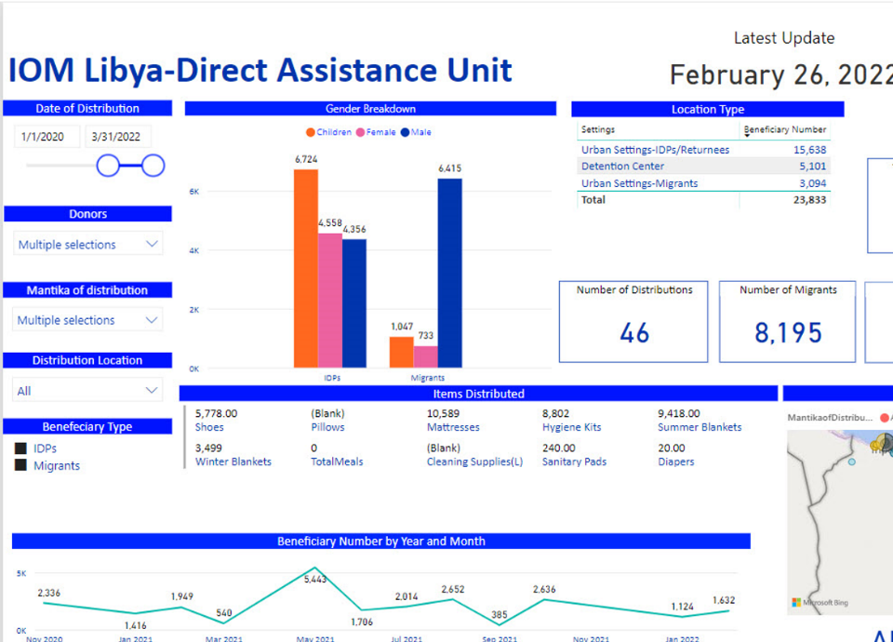

{OMISSIS}

Under the Direct Assistance Component, as of the end of February 2022, IOM has reached a total of 23,833 individuals (15,638 IDPS and 8,195 migrants) with the provision of lifesaving humanitarian assistance throughout a total of 46 distribution campaigns in 30 different locations in Libya.

COMPONENT III: MIGRANT RESOURCE AND RESPONSE MECHANISM (MRRM)

During the reporting period, MRRM field teams in {OMISSIS} and {OMISSIS} reached total of 15,860 migrants (10,859 men and boys and 5,001 women and girls) from 35 different nationalities, mainly from Sudan, Chad, Niger and Nigeria and living in different localities of {OMISSIS} and {OMISSIS} municipalities.
- Direct assistance
Among the migrants reached, 5,828 migrants including 925 households (HHs) received total of 7,070 non-food items. The NFI assistance provided included: hygiene kits, summer and winter clothing kits, mattresses, winter and summer blankets, tarpaulins, solar lamps, kitchen sets, sanitary pads and diapers. The following graph summarizes the quantity of each non-food item distributed during the reporting period.

Image 6: Percentages of non-food items distributed in {OMISSIS} and {OMISSIS}
Due to the increased need for food assistance requested by migrants, MRRM procured food kits that contained: 1 .Kg white flour, 1 kg Pasta, 1 kg Rice, 2 x 400 g canned Chickpeas, 3 x 400 g canned red beans, 3 x 400 g canned Green peas, 3 x 400 g canned beans, 1 Litre bottle veg oil, 2x400 g canned tomato paste,5 x 160 g canned Tuna, 0.5 Kg Sugar pack, 0.5 Kg Halawa pack, tea or 100 bags x 2 packets, 0.5 kg salt pack and 1 packet date biscuit (mini bars) 25 g/bar. The distribution of food kits started in December, 1,302 migrants (653 men and boys, 649 women and girls) including 273 households received 400 food kits.

{OMISSIS}
Image 7: MRRM Distribution, {OMISSIS} ©IOM, (2022).
Most of the assistance provided took place in urban settings and through door-to-door activities. As part of IOM’s do-no-harm approach, MRRM teams have supported 22 Libyans (15 men and boys, 7 women and girls) living in the same area as migrants with NFIs, through providing hygiene kits and healthcare services based on the need.
During this reporting period, MRRM teams reached new locations during their outreach to migrants gathering points. In {OMISSIS}, the team reached new locations such as {OMISSIS} and {OMISSIS} (25 km). MRRM {OMISSIS} reached new locations such as: {OMISSIS} Area (21 Km), {OMISSIS} Valley (70 Km), {OMISSIS} (70 Km), {OMISSIS} (87 Km), {OMISSIS} Valley (40 Km), {OMISSIS} Velly (35 Km), {OMISSIS} Valley (20 Km) and {OMISSIS} (92 Km) . In addition, to ensure IOM’s response to migrants in need, MRRM team in {OMISSIS} conducted regular meetings with the Libyan {OMISSIS} ({OMISSIS}) and Crisis Committee to address common challenges faced. In February 2022, the team collaborated with {OMISSIS}and donated 19 mattresses to be used for any referred emergency or vulnerable cases from host community and migrants to {OMISSIS}. As well, MRRM team in {OMISSIS} organized several meetings with community leaders of migrant communities residing in {OMISSIS}, including Nigerien, Chadian, Indian, and Sudanese community leaders.

The MRRM teams continued to maintain these contacts through regular communication and provided information about available MRRM services and updates about planned activities. MRRM teams in {OMISSIS} and {OMISSIS}have referred 177 cases to other units in IOM including 8 cases that were referred to protection unit, the referred cases were vulnerable women, persons at risk, child protection and GBV cases, one case was referred to Mental Health and Psychosocial Support (MHPSS) unit, and 168 cases were referred to Volunteer Humanitarian Return (VHR) unit.

Location | VHR | Protection | MHPSS
{OMISSIS} | 18 | 0 | 0
{OMISSIS} | 150 | 8 | 1
Total | 168 | 8 | 1
Number of Cases Referred to Other IOM Units

- Awareness raising

During the reporting period, 4,402 migrants (3,293 men and boys, 1,109 women and girls) were reached during a total of 378 awareness raising sessions. The awareness raising information capitalized on the materials developed under the #InformedMigrants campaign. Supporting Information, Educational, and Communication (IEC) materials were printed in Arabic, French, and English, and distributed during the sessions. MRRM teams distributed 3,516 pocket guides and 2,017 helpline cards.
Image 8: Gender Breakdown of Awareness Sessions Attendees

As part of the activities to raise awareness on the risks of irregular migration and to promote the IOM helpline number in {OMISSIS}, MRRM team painted an awareness raising mural at the Safe House Organization- a local organisation that works with migrants and provides shelter in {OMISSIS}. Two Libya woman artists were contracted to work on the mural; the artwork focuses on promoting the IOM helpline number while ensuring that the illustration style is positive and representative of the migrant communities in the area. The artwork was shared with the Safe House Organization and migrant focal points for their review and endorsement. On the implementation day, 31 male migrants were at the Safe House Organization while the artists were preparing the wall for the murals. The MRRM team implemented an awareness raising session discussing the risks of irregular migration and sharing information about the IOM services available for migrants. After the session, migrants joined the artists and took part in painting the mural.

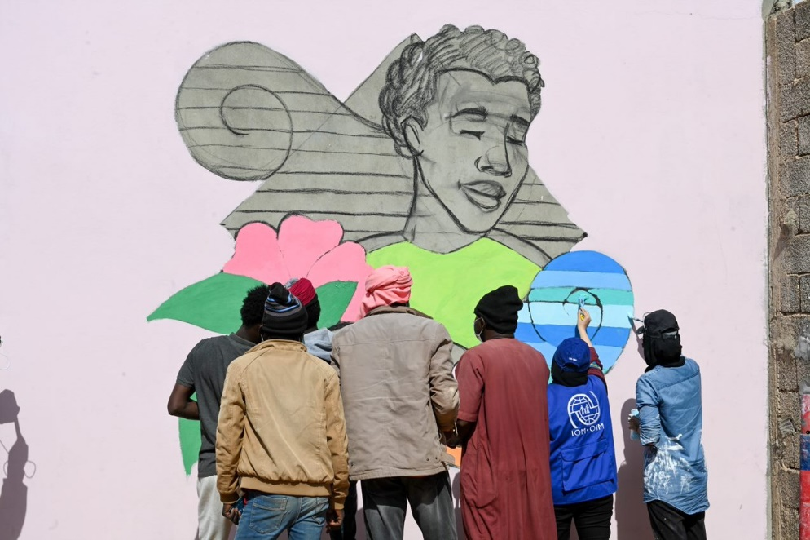
Image 9: Awareness Raising Mural Implemented at {OMISSIS}, © IOM (2022).
As part of the monitoring of activities in the field and the capacity building of the staff, MRRM arranged for a monitoring visit to {OMISSIS} to support the field team and implement an Accountability to Affected Population (AAP) training session for migrant community leaders and staff. Community and field assistance also discussed with the {OMISSIS} team on the daily challenges they are facing, and shared recommendations for improvement based on their observations. The team conducted rehearsal session for case workers on how to implement awareness raising sessions to ensure the quality of information and facilitation style is consistent. Additionally, a refresher session on how to collect human interest stories was conducted in order to enhance visibility and reporting.
- Protection
During the project, IOM Protection team provided specialised protection assistance to 135 migrants (47 women, 42 men, 27 boys and 19 girls). The team conducted 71 (9 women, 16 men, 27 boys and 19 girls) rapid screenings and 64 (38 females and 26 males) in-depth vulnerability assessments and referrals. This assessment helped the identification and provision of support to survivors of abuse, torture, or trafficking in persons and to children at risk. Moreover, among the identified and assisted migrants, two migrants (one man and woman) were referred internally to IOM’s MHPSS team to receive assistance.
IOM Protection team continued its community-based protection activities through outreach activities in urban locations and various detention centers to help identify evolving needs and vulnerabilities in the community. 29 Outreach and monitoring visits continued to take place in urban settings in {OMISSIS} and {OMISSIS} and four detention centers in {OMISSIS}: {OMISSIS}, {OMISSIS} and {OMISSIS}.
- Health
At the {OMISSIS} clinic, the medical doctor and nurse received migrants and provide medical assistance required, including medical consultations, surgical consultations, minor surgical management, regular dressings, health awareness and promotion, and referral to secondary and/or tertiary health centres. The clinic is provided with all the required medicines, consumables and supplies required to support the primary health care needs and are replenished on needs basis from MHD medical warehouse. Similarly, any additional equipment is added on need basis and out of order equipment is repaired or replaced to ensure continuity of services.
In {OMISSIS}, the medical team, in coordination with the MRRM team conducted daily mobile outreach visits to different communities, equipped with required medications, consumables and supplies required for mobile primary health care.
{OMISSIS} Outreach medical visits
During this reporting period, health consultations and assistance were provided to a total of 3245 migrants in communities and at the {OMISSIS} MRRM clinic (19.4% of medical consultations were provided to children under 18 years old, 22.9% were provided to women, 57.5% were provided to men).
The most common health problems among migrants were dermatological diseases (22%) including large number of scabies cases, followed by acute upper respiratory diseases (20%) musculoskeletal disorders (15%), and gastrointestinal diseases (13%).
Zwara MRRM Medical Visits for migrants - Urban Areas
Time period | Number of beneficiaries |  |  |  |  |  |  |  | Total
 | Males |  |  |  | Females
 | 0-5 Y | 6-17 Y | 18-59 Y | 60+ Y | 0-5 Y | 6-17 Y | 18-59 Y | 60+ Y
Sept21 - Feb22 | 163 | 234 | 1836 | 31 | 146 | 89 | 705 | 41 | 3245

Referral to Hospitals by {OMISSIS} MRRM team:
During the project period, a significant number of cases were referred by the {OMISSIS} medical team to secondary and tertiary health care facilities; some of those referrals were urgent and lifesaving, and some of them are sick children, pregnant women for antenatal, natal and postnatal care, psychiatric cases and highly suspected TB cases as well as COVID-19 screening and management. The referrals were both for diagnostic purposes and inpatient care. In order to facilitate such referrals, IOM used its already established mechanism of agreements with hospitals and ambulance service, which ensured swift and smooth referrals and remained instrumental in preventing mortality and disabilities.
During the reporting period a total of 266 cases were referred to hospitals for specialized care.
DP.2200 Referrals (Zwara)
Project period | Number of beneficiaries |  |  |  |  |  |  |  | Total
 | Males |  |  |  | Females
 | 0-5 Y | 6-17 Y | 18-59 Y | 60+ Y | 0-5 Y | 6-17 Y | 18-59 Y | 60+ Y
Sept2021- Feb2022 | 10 | 20 | 102 | 2 | 6 | 7 | 112 | 7 | 266

Imagine 11: Breakdown of referrals at the {OMISSIS}Clinic

{OMISSIS} Outreach medical visits
During the reporting period, a total of 1,869 health consultations and assistance were provided to migrants in the communities, out of them 23.43% consultations were provided to women, 22% consultations were provided to children under 18Y, and 54.3% were provided to men.
The most common health problems among migrants were gastrointestinal diseases (15%) followed by musculoskeletal diseases and dental oral disorders (13%), dermatological disorders and management of chronic non-communicable diseases (10 %) and upper and lower acute respiratory diseases (9%).
Medical consultations – Bani Waled
Project period | Number of beneficiaries |  |  |  |  |  |  |  | Total
 | Males |  |  |  | Females
 | 0-5 Y | 6-17 Y | 18-59 Y | 60+ Y | 0-5 Y | 6-17 Y | 18-59 Y | 60+ Y
Sept2021-Feb2022 | 139 | 97 | 959 | 57 | 99 | 80 | 400 | 38 | 1869

Referral to hospitals by {OMISSIS} MRRM team:
Cases were referred by the {OMISSIS} medical team to secondary and tertiary health care facilities; many of those referrals were urgent and lifesaving in addition to cases of sick children, pregnant women for antenatal care, COVID-19 screening and management and highly suspected TB cases. The referrals were both for diagnostic purposes and inpatient care. In order to facilitate such referrals, IOM used its already established mechanism of agreements with hospitals and ambulance service, which ensured swift and smooth referrals and remained instrumental in preventing mortality and disabilities.
During the project period from September 2021 until February 2022, total of 195 cases were referred to hospitals for specialized care under this project in {OMISSIS}.

Referrals (Bani Waled)
Project period | Number of beneficiaries |  |  |  |  |  |  |  | Total
 | Males |  |  |  | Females
 | 0-5 Y | 6-17 Y | 18-59 Y | 60+ Y | 0-5 Y | 6-17 Y | 18-59 Y | 60+ Y
Sept 2021 – Feb 2022 | 8 | 10 | 84 | 11 | 6 | 5 | 60 | 11 | 195

Imagine 11: Breakdown of referrals at the {OMISSIS} Clinic

COMPONENT IV: CAPACITY BUILDING
The purpose of capacity building components is to improve Libyan officials’ knowledge on human rights-based migration management. It aims to promote a comprehensive and effective governance of migration in Libya, by specifically targeting front line officers on migration management knowledge and procedures.
Within the reporting period, IOM organized a Disaster Risk Reduction (DRR) and preparedness capacity workshop (29-30 November 2021) for national stakeholders in {OMISSIS}. The workshop was aimed to support in the development of an effective disaster risk mitigation plan as well as adequate policies, to be able to mitigate the risks related to natural hazards and plan emergency response in such events.
The workshop, which was held at the UN compound in {OMISSIS}, was successful and reached 14 Libyan officials (13 M/ 1 F) from seven governmental bodies; Ministry of Social Affairs (3), House of Representatives (1), Libyan Humanitarian Relief Agency (1), Libyan Red Crescent (1), Municipalities (6), Ministry of Environmental affairs (1), Ministry of Housing and Construction (1).
The DRR workshop presented the participants with the key concepts of DRR, Sendai Framework, and guidelines to both structural and non-structural risk mitigation measures to be adopted. It empowered participants with the effective and successful preparedness, response, and recovery mechanisms to be followed upon occurrence of natural disaster, and shared the best practices and lesson learnt from other countries.
The workshop was completed with a simulation session, during which participants were able to reflect on the possible coordination mechanisms, preparedness, and response plan of a sudden flood. The participants shared to be ‘very satisfied’ with the overall workshop as well as the usefulness of the workshop to their field of work (see M&E Data Analysis report for DRR Workshop in annex).

Progress Made towards Incorporating Cross-cutting Themes

Accountability to Affected Populations, Gender Mainstreaming, and Conflict Sensitivity

Since the commencement of the project, IOM actively engaged the community and local authorities in each step of the project to engage in the decision-making process for the benefit of the entire community. For example, under the Community Stabilization activities, regular meetings and events were conducted with community members and local authorities to ensure regular update on activities implementation and feedback. All interventions have been conducted while ensuring that the needs of the most vulnerable are addressed. Youth and women empowerment are one of the IOM’s priority areas. For this reason, under the CS component specific projects focused to empower capacities of women and youth to engage with other community members and to act as agent of change in their community. Therefore, conflict sensitivity assessments are rigorously conducted to ensure that interventions will be context appropriate and contribute to address drivers of instability in a sustainable manner.

With regard to the provision of assistance directly to migrants, it should be noted that women are very much a minority within the migrant population in Libya being usually approximately 10 per cent and tending to be in a vulnerable position. Specific efforts were made to ensure that women and specifically female headed households, benefited from the available assistance. This was made possible through the engagement of community leaders and female migrants who act as focal points within their networks. Approximately 85 per cent of the households in Bani Waleed and Zwara are female headed.

As part of IOM’s commitment to mainstream accountability, MRRM conducted a virtual capacity-building session on Accountability to Affected Populations (AAP), explaining AAP as a concept and introducing available Complaint and Feedback Mechanisms (CFM) in Libya, and how MRRM teams can promote CFM among migrants. MRRM team leaders and case workers in {OMISSIS} {OMISSIS}, {OMISSIS}, {OMISSIS}, {OMISSIS}, {OMISSIS}, and {OMISSIS} attended the session.
For the CB component, IOM actively sought to invite female participants for the DRR workshop and ensured balanced gender representation for the speakers.

Progress Achieved Compared with the Indicators in the Results Matrix

 |  | Indicators |  | Baseline |  | Target | Data Source and Collection Method |  | Progress made during reporting period | Cumulative progress
Objective:  Contribute to resilience of crisis-affected populations in Libya |  | % of beneficiaries (IDPs, migrants or host community) who report improvement in their lives as a result of the services/trainings received |  |  |  | 75% | Monitoring reports,  Satisfaction surveys |  | Survey analysis on going. Results will be included in the final report (CS section) | 78% of beneficiaries participated in NFI PDM reported to have been satisfied with IOM’s assistance (this is DA section only).  Survey analysis on going. Results will be included in the final report (CS section)
Outcome 1:  Crisis-affected communities have enhanced social cohesion and capacities to address community issues |  | % of CSO participants report increased capacity to address community issues  % of participating community members who report improved perception of other tribes, migrants, IDPs and returnees in their community |  |  |  | 70%  70% | Survey among community members in the selected locations  Participants' feedback forms |  | 98% of CSO reported increased capacities to respond to community needs  90.9% of CSOs reported that skills and knowledge learned during the training will be useful for their daily work  Survey analysis on going to reply to “% of participating community members who report improved perception of other tribes, migrants, IDPs and returnees in their community” . Results will be included in the final report (CS section) | 98% of CSO reported increased capacities to respond to community needs  90.9% of CSOs reported that skills and knowledge learned during the training will be useful for their daily work  Survey analysis on going to reply to “% of participating community members who report improved perception of other tribes, migrants, IDPs and returnees in their community” . Results will be included in the final report (CS section)
Output 1.1:  Capacity of local CSOs is enhanced |  | # of CSOs capacitated  # of community members (IDPs, migrants or host community) who participated in community stabilization and cohesion promotion activities |  | 5 |  | 10  2000 | Project records  Project records |  | 25  1414 (732 men and 682 women) of community members (IDPs, migrants or host community) who participated in community stabilization and cohesion promotion activities | 25  1618 (892 men and 726 women) of community members (IDPs, migrants or host community) who participated in community stabilization and cohesion promotion activities
Activities 1.1:
1.1.1 | Conduct meetings with communities
1.1.2 | Training/capacity building for CSOs
1.1.3 | Provision of grants to CSOs for implementation of social cohesion and community engagement projects

Outcome 2:  Crisis-affected community members have improved access to basic services and community infrastructure |  | % of the targeted community members indicating access to improved basic services and community infrastructure |  |  | 80% |  | Survey among community members in the selected locations | N/A Outcome assessment survey ongoing. Will be reported in the final report |  | N/A Outcome assessment survey ongoing. Will be reported in the final report
Output 2.1:  Common infrastructures are rehabilitated to provide essential services |  | # of CIPs implemented  # of people benefiting from the CIPs | 29 |  | 10  10000 |  | Weekly progress reports  Field monitoring | 13  Approximately 30 000 of people benefiting from the CIPs |  | 14  Approximately 40 000 of people benefiting from the CIPs
Activities 2.1:
2.1.1 | Selection of contractors based on call for bids
2.1.2 | Rehabilitation of common infrastructure and/or provision of equipment as per the selected infrastructure projects (CIPs)
2.1.3 | Monitoring by IOM engineers for quality assurance

Outcome 3:  Migrants, IDPs and host communities, where relevant, have increased access to humanitarian direct assistance | % of beneficiaries who are satisfied with the received assistance |  |  |  | 70% |  | Survey |  |  | 78% satisfaction reported as per the NFI PDM
Output 3.1: DA  Migrants, IDPs and, where relevant host communities, received NFIs | # of families receiving full NFI kits |  |  |  | 2400 |  | Interviews, written feedback from CSOs, workshop attendance | 5,177 individuals (4,144 male, 429 female and 604 children) |  | 2,873 families and 3,252 individual migrants (18,656 individuals – 6,878 men, 4,826 women, and 6,952 children) benefited from NFI kits
Activities 3.1:
3.1.1 | Pre-distribution need assessment
3.1.2 | Procurement of NFIs
3.1.3 | Distribution of NFIs

Outcome 4: MRRM  Migrants have improved access to humanitarian assistance that improves their well-being | % of beneficiaries reporting satisfaction with MRRM services |  |  |  | 70% |  |  | Will be reported on in the final report |  | Will be reported on in the final report
Output 4.1:  Migrants have access to integrated multisectoral assistance | # of primary healthcare consultations provided by IOM's health teams  # of referrals to secondary and tertiary health facilities  # of protection assessments and support provided  # of beneficiaries loose NFIs, hygiene items and basic food packages (disaggregated by sex)  # of referrals to VHR and other IOM or non-IOM programmes |  |  |  | 4,000  180  50  2,800  750 |  | Database records, reports, pictures  Database records, reports, pictures  Database records, reports, pictures  Database records, reports, pictures | 5114 - primary healthcare consultations  461 referrals to secondary and tertiary health facilities  Protection assistance to 135 migrants (47 women, 42 men, 27 boys and 19 girls)  6,595 (4,062 male, 2,533 female) beneficiaries received loose NFIs, hygiene items and basic food packages  168 cases referred to VHR, 1 case referred to MHPSS, and 8 cases referred to protection. |  | 9443 primary healthcare consultations  574 referrals to secondary and tertiary health facilities  154 protection assessments and support provided (56 women, 52 men, 27 boys and 19 girls)  13, 623 beneficiaries received loose NFIs, hygiene items and basic food packages  314 cases referred to VHR, 2 cases referred to MHPSS, 12 cases referred to protection.
Activities 4.1:
4.1.1 | Registration and profiling of all migrants and host community beneficiaries targeted through MRRM
4.1.2 | Provision of basic health care services and specialized assistance for identified vulnerable migrants
4.1.3 | Conduct assessment and provision of protection services in coordination with IOM specialized unit
4.1.4 | Distribution of loose NFIs, hygiene items and basic food packages
4.1.5 | Registration and referral to other specialized services

Outcome 5:  Strengthened capacity of local authorities to address migrants' needs | % of trained officials who report the trainings have increased their understanding of the topic |  |  |  | 70% |  | Event reports, feedback forms | 100% |  | To be reported in the final report
Output 5.1:  Local authorities have increased understanding of key topics | # of officials trained |  |  |  | 150 |  | Event reports, photos, feedback forms, registration sheets | 14 officials trained |  | 84 officials trained
Activities 5.1:
5.1.1 | Organization of training for officials in Migration Governance
5.1.2 | Organization of training for officials in HBM
5.1.3 | Organization of training for officials in MICIC

Challenges Encountered and Actions Taken
Challenges | Actions Taken
Security concerns while visiting migrants at community locations were also a matter, our teams sometimes find themselves questioned by public and/or threatened or interrogated by military check points and armed groups. | Immediate reporting of security incidents to the IOM security department and senior management. In addition, IOM team maintained low profile during the outreach visits to avoid any sensitive issues against the reached migrants.
Public hospitals with very limited staff and sometimes no staff at all. In {OMISSIS} and {OMISSIS}, they have an additional moral and financial burden, where some cases needed an immediate lifesaving intervention or/and very special long term medical care, which sometimes cannot be provided at public hospitals due to different administrative and technical reasons. | IOM managed to establish referral linkages with some private health entities and also with public sector hospitals outside {OMISSIS} and {OMISSIS} (in {OMISSIS}), where IOM medical team managed to assist the lifesaving interventions on case-by-case basis, utilizing the services of both private sector and public sector (in {OMISSIS}) to ensure continuity of services; and as per the project capacity.
Limited or no access to children vaccination especially for migrants with no official documentation. | MRRM medical teams organized multiple campaigns where 10 to 15 children who missed their vaccination doses were taken to Vaccination centres and vaccinated after arrangements and facilitation with NCDC branches.
Under CS Output 1, the expected target was 2000 beneficiaries. Due to the Covid-19 pandemic and restriction measures, IOM had to modify some activities that foresaw large number of beneficiaries. For example, handover of Community Improvement Projects (CIPs), community engagement activities in schools, and large community events. | Total beneficiaries reached under this output are 1618 (892 men and 726 women). To overcome the challenge, IOM increased the number of CSOs involved in the capapcity building initiative under the same Output by organizing small scale, outdoor activities – as applicable, and providing face masks and sanitizers.

Conclusion

During the third reporting period of this project (1 September 2021 – 28 February 2022), IOM has progressed in implementing the final stage of project activities. Throughout the project period, this project capitalized on the experience and gains already achieved under the previous project supported by the Africa Fund in 2020 which has had a distinct positive impact on the pace and efficiency of implementation of this project.
The Community Stabilization team have continued the engagement of the communities previously worked in while expanding to neighbouring areas in the South of Libya, which are particularly hard for many actors to reach, providing services and engagement in a meaningful way as per consultations with the targeted beneficiaries. During this project period, 13 CIPs have been finalised in coordination with communities, CSOs and local government, impacting approximately 40,000 beneficiaries.
Under Direct Assistance, 5,177 people including children benefited from the provision of NFIs across 11 detention centres and 5 urban settings. Items that were distributed and received by beneficiaries include winter and summer blankets, winter and summer clothes, mattresses, individual hygiene kits, kitchen sets, and tarpaulins. NFI kits have been carefully designed to meet the differing needs of individuals (men/women and children) and they differ in winter and summer.
The MRRM team, during this reporting period reached 10,859 migrants in {OMISSIS} and {OMISSIS}. The MRRM team were able to successfully deliver activities, ensuring that vulnerable populations and particularly migrants, have access to much needed life-saving assistance. Through this multi-faceted mechanism, beneficiaries have received NFIs, food assistance, primary health care consultancies, referrals to tertiary health care facilities, referrals to protection (including MHPSS) services and access to awareness raising sessions.
The CB component successfully delivered a workshop on Disaster Risk Reduction for national stakeholders. Drawing attention to the increase in natural hazards due to climate change and the components to migration related to such events, the workshop targeted local and national stakeholders from government entities and NGOs. This training was specifically requested previously by government counterparts and was well received by its participants as per the post-test surveys.

Expenditures and Resource Utilization
No financial report required.

Annexes
Annex 1- Monitoring and Evaluation Dashboard, Community Stabilization
Annex 2- CSO Capacity Building Workshop Report
Annex 3 – The Story of Mostafa Maroo, MRRM Beneficiary in Zwara
Annex 4 – The Story of Mariam Yusuf, MRRM Beneficiary in Bani Waleed
Annex 5 – M&E Data Analysis report of DRR Workshop

The CSAs were developed with funding support from several projects as they are utilized for all stabilization activities in project locations, including those funded under this grant.
The expected target was 2000 beneficiaries. Due to the Covid-19 pandemic and social distancing measures, IOM had to modify some activities that foresaw large number of beneficiaries. For example, handover of Community Improvement Projects (CIPs), community engagement activities in schools, large community events. For this reason, total beneficiaries reached under this action are 1618 (892 men and 726 women). To overcome these challenges, IOM increased the number of CSOs involved in the capacity building initiative under the same Output.
From the assessment conducted by IOM early 2020
Participant numbers differ as 3 people did not respond to the survey
The Km distance is based on the distance from MRRM base to migrants gathering point locations.
Information about the AAP training are provided under II.1. AAP mainstreaming section.
The Sendai Framework can be found at https://www.undrr.org/publication/sendai-framework-disaster-risk-reduction-2015-2030

