FINAL Report to
Italian Ministry of Foreign Affairs and International Cooperation

MULTI-SECTORAL SUPPORT FOR CRISIS-AFFECTED POPULATIONS IN LIBYA

{OMISSIS}
Photo: IOM Medical Team providing treatment to a migrant. IOM 2022

Executing Agency | International Organization for Migration (IOM)
Project Identification | IOM Project Code: DP.2200
Grant Reference ID
Geographical Coverage | National
Beneficiaries | Migrants in Libya, Libyans (host community and IDPs), Local authorities, CSOs
Partner(s)Partner(s) | Relevant government authorities at national and local level
Management Site | Tripoli, CO, LIBYA
Relevant Regional Office(s) | RO Cairo, EGYPT
Project Period | 1 September 2020 – 28 February 2022
Reporting Period | 1 September 2020- 28 February 2022
Date of Submission | 31 May, 2022
Total Confirmed Funding | 4,500,000 EUR
Total Funds Received to Date | 4,455,446.00 EUR
Total Expenditures | 4,455,446.00 EUR

Summary of Key Achievements during the Reporting Period
The project, ‘Multi-Sectoral support to Crisis-Affected Populations in Libya’ comprises of four components:
- Community Stabilization (CS)
- Direct Assistance (DA)
- Migrant Resource and Response Mechanism (MRRM)
- Capacity Building (CB)

Through the interlinkage of these components, the project aimed to contribute to the resilience of crisis-affected populations, including migrants and Internally Displaced Persons (IDPs) in Libya.
During the reporting period, IOM has delivered essential services to migrants and vulnerable communities contributing to the resilience of crisis-affected populations in Libya.
IOM emphasized community engagement and the process of creating the conditions for communities to co-exist peacefully, resolve tensions through non-violent means, restore trust in local leadership and regain the agency, within crisis affected groups to drive recovery processes. The Community Stabilization approach included components that encourage individuals to work together towards collective goals. Under the Community Stabilization component, all planned activities were completed.
In total, 1618 (892 men and 726 women) people from different community groups were involved in consultation, community engagement, social cohesion, and capacity building activities to promote positive relationships and peaceful coexistence (Outcome 1). In addition, following the recommendations from the consultations, IOM completed 14 Community Improvement Projects (CIPs) that are now fully functional and can be used by a population of approximately 40,000 people (Outcome 2).
Under the Direct Assistance component, IOM has assisted a total of 23,833 (11,022 male, 5,255 women and 7,556 children) individuals, from those 15,404 were IDPs and 8,429 were migrants, with provision of lifesaving humanitarian assistance through a total of 46 distribution campaigns in 30 different locations throughout the State of Libya. Items that were distributed and received by beneficiaries included winter and summer blankets, winter and summer clothes, mattresses, individual hygiene kits, kitchen sets, and tarpaulins.
Under the Migrant Resource and Response Mechanism (MRRM) component, 30,146 migrants (9,035 women and girls) were reached through the various humanitarian services the unit is providing. Particularly 12,856 migrants, including more than 2,000 households, received various NFIs (such as hygiene kits, summer and winter clothing kits, summer and winter blankets, tarpaulins, solar lamps, kitchen sets, mattresses, sanitary pads and diapers), 1,302 migrants received food assistance, primary health care consultations were provided, and 11,566 migrants were reached during awareness raising sessions, informing migrants about the risks of irregular migration and alternative pathways.
MRRM is a modality of programme implementation that uses a comprehensive and community-centred approach to bring together a wide range of services and assistance that IOM provides to migrants. It provides vulnerable migrants with information, access and referral to a wide variety of targeted humanitarian services. Migrants living in urban areas as well as host community with very vulnerable cases benefited from MRRM services.
Under the Capacity Building (CB) component, IOM implemented four training courses and a workshop which all took place in 2021. Reaching more than 82 officials (11 women, 71 men) from across 21 different governmental entities, the courses demonstrated willpower and readiness from Libyan authorities to execute recommended best practices, while being observant of COVID-19 and health regulations. In addition, it enabled IOM to solidify strong collaborative relationships with the Government of National Unity (GNU) particularly in {OMISSIS}.

Progress Made towards Realizing Outcomes and Outputs

COMPONENT I: COMMUNITY STABILIZATION

Under this component, with the objective to support the stability and resilience of conflict-affected communities, IOM built on the achievements of the previous MEACI project (September 2017-December 2020), which allowed IOM to establish a presence within the communities of implementation and gain the trust of both Libyan authorities and the wider community.
1. Rapid and conflict sensitivity assessments in project locations
In the first year of the project, IOM completed assessments and community consultations to inform the Community Stabilization (CS) programme. IOM assessed four locations in the {OMISSIS} ({OMISSIS}, {OMISSIS}, {OMISSIS}, {OMISSIS}) and two locations in and around {OMISSIS} ({OMISSIS} muhalla, {OMISSIS}) using a methodology comprised of a desk review of existing documents, key informant interviews, and focus groups discussions. Three reports were finalized within the reporting period (Annex 1, 2 and 3) based on these focus group discussions with community members and key informant interviews with officials. These consultations provided essential information on demographic, social, and economic issues, as well as the overall quality of public services in the areas of CS programming.
Integral components of CS programming are ensuring that the needs of the most vulnerable are addressed, and that interventions create an environment in which society can thrive. This requires a carefully designed ‘do no harm’ strategy, and conflict sensitive lens. For this reason, as a second step in the implementation of CS activities, IOM completed conflict sensitivity assessments (CSA) in {OMISSIS}, {OMISSIS} and {OMISSIS} ({OMISSIS} muhalla), and updated the 2018 CSAs previously conducted in {OMISSIS}, {OMISSIS}, {OMISSIS} and {OMISSIS} . These assessments provided an overview of key local dynamics, peace and conflict factors, a map of local stakeholders, and a conflict sensitivity matrix with programmatic recommendations to minimize the risk of exacerbated conflicts. Based on the results of the conflict sensitivity assessments (CSA), activities were then carefully designed and implemented.
2. Coordination meeting with project staff
A coordination meeting was organised from 18 to 20 January 2022 in {OMISSIS} with the participation of twenty-six of IOM’s Community Stabilization field staff and engineers from {OMISSIS}, {OMISSIS}, {OMISSIS}, {OMISSIS} and {OMISSIS}. Among the objectives were to jointly review current and past IOM activities, discuss challenges and opportunities, and plan the next phase of activities for 2022. Topics of technical sessions covered social cohesion and community engagement, monitoring and evaluation, internal communication, teamwork, and gender awareness in the design and implementation of projects. The meeting also included a review of community consultation and assessment mechanisms as well as identification of ways to strengthen linkages with other IOM programmes.
Outcome 1: Crisis-affected communities have enhanced social cohesion and capacities to address community issues
Under this outcome, IOM brought together groups from different backgrounds to promote positive relationships and peaceful coexistence reaching a total of 1618 community members (892 men and 726 women). During the project period, IOM completed several activities aimed at 1) engaging community members and local authorities in consultation throughout project implementation, 2) building the capacity of local CSOs and staff to implement projects with a focus on stabilization and social cohesion, and 3) promoting community engagement and social cohesion through community-based and peacebuilding initiatives.

- Community Management Committees (CMCs) and community consultations
During the project, IOM continued to assess and consult communities in all project locations applying several methodologies. In {OMISSIS} and {OMISSIS}, meetings in muhallas of the cities were organized through the Community Management Committees (CMCs): a cross-section of tribal representatives who monitor and support IOM’s community stabilization efforts, advising on local conditions and concerns. The CMCs were set up to address the most pressing concerns of communities by having a representative, locally driven, transparent, and accountable identification of community needs. In other project locations, IOM conducted regular community consultations by bringing together people from different tribes and social groups to jointly identify the most urgent community concerns, to agree on proposed solutions, and to be present during handovers upon project completion. In total, more than 200 community members were consulted.

- Promote community engagement and social cohesion with community-based initiatives
In March 2021, IOM opened a Call for Proposals (CfP) to identify actors who were able to respond to the community needs through community engagement and social cohesion projects. The CfP was open for one month. Local civil society organizations (CSOs) operating in various programmatic areas (including youth engagement, peacebuilding, localized cross-tribal activities, education, sports, women’s empowerment, and support to children and families with disabilities) applied to the CfP. The selected grant was from CSO {OMISSIS}, an organization established in 1992 in {OMISSIS} with local branches in {OMISSIS} and {OMISSIS}. {OMISSIS} has experience in education and capacity building activities targeting women and youth, including media and technology education, social cohesion, mediation, and facilitation. Under the guidance and technical support of IOM, {OMISSIS} implemented activities from December 2021 to February 2022, focused on women empowerment and social cohesion in the district of {OMISSIS}.
Pre-existing tensions between different ethnic and tribal groups in this area, and more generally in {OMISSIS} Libya, have been high since early 2019. Women have a limited role in local decision-making and public affairs. In addition, women and girls experience severe physical and psychological impacts of the conflict caused by the loss of lives, including family members, as well as the loss of livelihoods and shelter in other cases. At the same time, women are restricted by social norms and expectations; narrow social interactions exacerbate tribal and ethnic divides and self-isolation. Women are dissuaded from attending mixed-gender trainings or activities, and each city lacks suitable spaces for them to meet, dialogue, learn, and share.
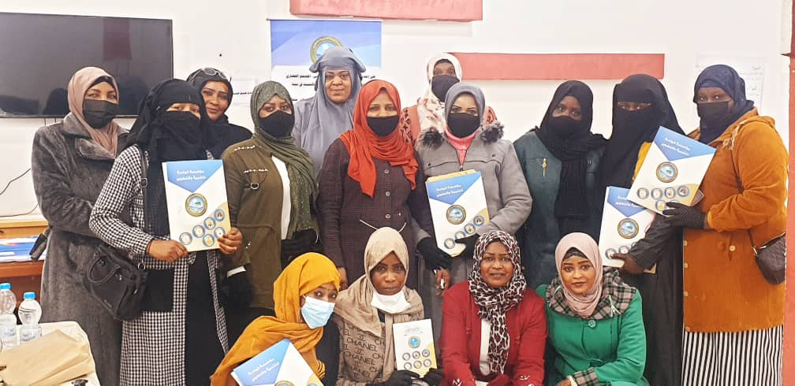
The activities involved seventy-five women from {OMISSIS}, {OMISSIS} and {OMISSIS} from different tribes living in the area ({OMISSIS}, {OMISSIS}, {OMISSIS}) in an 8-day training aimed to improve dialogue and facilitate skills to support local communities through establishing peace-committees in their villages with the aim to promote a culture of peace and active citizenship. A final ceremony was conducted on February 26, 2022, to introduce the three groups to each other and start the discussion on the committee’s creation. In each group, several participating women volunteered to create a network and ensure regular exchange on their plans. The three groups agreed on the importance of sharing the knowledge and skills acquired (local conflict resolution, role of women in peace and conflict, conflict resolution and mediation skills) with women that didn’t have access to the training. {OMISSIS}, a participant from {OMISSIS} said: “I think women are active members of our society and we’re often involved to solve issues in and outside our family, but unfortunately most of us feel really isolated, sitting at home alone, allowed only to meet with relatives. During the training, I understood that women coming from different tribes in our area are experiencing the same condition and this immediately creates a strong bond between us. Now we just need to change our society!”.
Picture: {OMISSIS}, January. Certificates distribution and closing ceremony of the “women empowerment and social cohesion initiative in collaboration with {OMISSIS} CSO. © IOM, (2022).
To evaluate the impact, IOM utilized several tools: pre and post-tests and training evaluation, observation and monitoring forms collected from the field staff during the activities and feedback from trainers and beneficiaries. The overall rate of the correct responses in the post-test was 65%. For anyone who tested below 70% in the post test, IOM requested further information as to why – whether it be the trainer, or the materials. Most participants justified this by saying that it was their first time to attend this type of training and to hear about peace processes, mediation and dialogue, and that despite the training content and materials being appropriate, additional time would have been appropriate to fix all the new concepts. Nonetheless, participants were satisfied with the training as shown in the training evaluation filled in by each participant. Below a table summarizing the results:
Questions | Agree/ Strongly agree replies
Evaluation about training program
The course addressed all the learning objectives | 93.33%
The course provided me with new information and new skills | 95.56%
The material provided was adequate and it will be a useful reference for the future | 86.66%
The course was interesting and stimulating to take part in | 97.78%
Evaluation about trainer performance
Trainer was able to present and explain the content of the training | 86.67%
Trainer was able to balance between theory and practical exercise | 93.33%
Trainer was able to motivate and keep the attention of trainees | 91.11%
The training met my expectations | 91.11%
Overall experience evaluation and participation
I felt included in group activities and discussions | 95.55%
The activity helped me to connect with people outside my own community | 91.11%
There was a positive atmosphere among participants | 100.00%

Participants were particularly happy to have had the opportunity during the training to practice dialogue and mediation skills in groups and to be able to express their opinion with practical exercises aimed to improve self-confidence in public speaking. The trainer reported to IOM: “Most women living in these remote areas have a low education level, they’re not aware of their rights and often face discrimination. During the training, they had space to discuss several issues affecting their life for example tribal/ethnicity discrimination faced by those married with non-Libyan or in mix wedding ({OMISSIS} /{OMISSIS} ) and the isolation their children experience; social exclusion for those living far from schools, hospitals, services and issues related to physical and psychological violence inside the family or in the community. It was very important for them to understand how the concept of peace, mediation and dialogue can improve their life”.
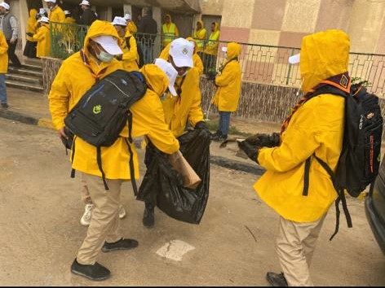
Meanwhile, preparations started in August 2021 for several activities with the Libyan {OMISSIS} Association in {OMISSIS} , {OMISSIS} and {OMISSIS} , with the aim to to empower youth to enhance a sense of community responsibility and ownership. The Scouts are a well-known and well-respected national organization recognized by the Ministry of {OMISSIS} and {OMISSIS} , with extensive experience in involving local youth in sports, arts and cultural activities. After several consultations with {OMISSIS} groups in each location, IOM supported the implementation of an environmental awareness and community improvement campaign in February 2022. IOM and the {OMISSIS} identified locations of broad community access (public gardens, schools, roads) that were targeted by volunteer groups with cleaning, painting, planting trees and flowers. Public sessions with community members and sessions organized in primary schools for elementary school children took place to discuss community responsibilities to care for the environment and strengthen community cohesion.
Picture:—During the day the scout groups in {OMISSIS} clean several important locations with the support of community members. @IOM 2022

collaboration with Al Waha CSO. © IOM, (2022).
In February, several events were organised reaching more than 450 participants. In {OMISSIS}, 70 youth participants cleaned, and planted trees in one of the main streets of the city leading to the Elmegarief Hospital. One participant noted: “We really enjoyed it, and we received support from people that were stuck in the traffic. Some of them joined us to clean, it was a very good example”. In {OMISSIS}, the activities took place in four public schools: {OMISSIS}, {OMISSIS}, {OMISSIS} and {OMISSIS} where 250 youth and students – primarily young women – participated. Participants cleaned, painted the outdoor spaces and planted fig and olive tree seeds. A session in each school was organised to explain the positive impact of conducting similar activities, the importance of collecting garbage and recycling plastic in common and private spaces and organising a student’s committee to take care of the trees. In {OMISSIS}, 155 youth were involved. Here, the Scouts prioritized peripheral locations important for the daily life of people – a market, a school and two commercial streets. The beautification process included cleaning, collecting garbage with the support of the municipality, painting sidewalks, walls and planting trees.
In addition to a daily report of each activity and feedback from participants, IOM conducted a satisfaction survey with 49 participants to measure engagement during the activities and to ensure connections between participants were made. Below is an overview of the results. For the completed analysis see Annex 4. One hundred per cent of respondents reported having the opportunity to collaborate with their peers in a joint project to improve common spaces in their city. Also, they reported that during the activities, the atmosphere helped them in connecting with new people and build connections; all of them felt included and engaged in the activities.
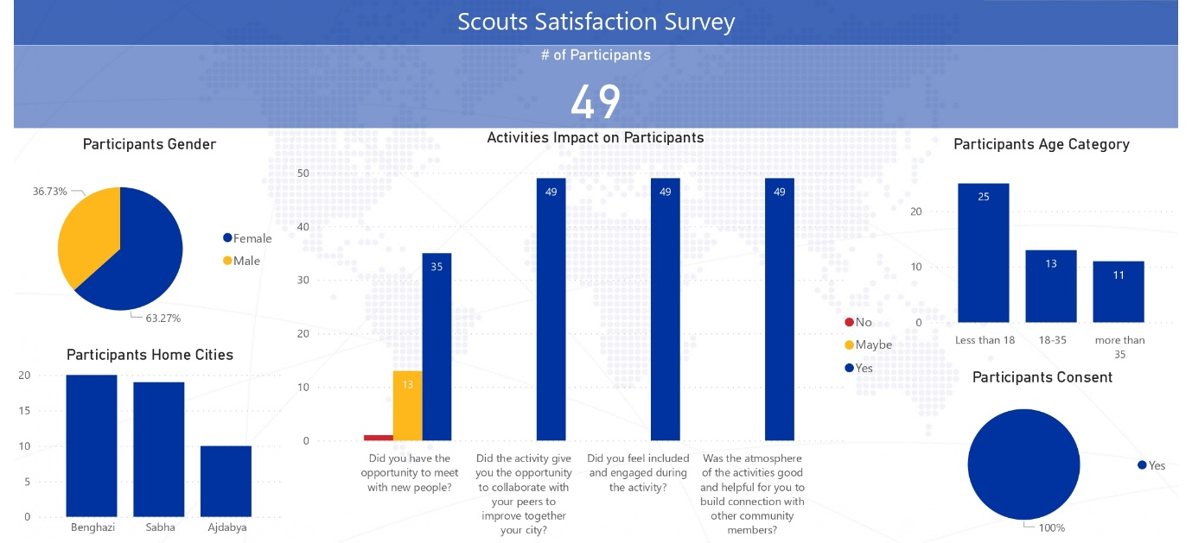

Finally, in project locations in the {OMISSIS} of Libya ({OMISSIS} and {OMISSIS}), outreach to the municipalities of {OMISSIS} and {OMISSIS} through community consultations highlighted the lack of access to information sources at primary and secondary levels of education, as well as the lack of public library facilities. IOM worked with the {OMISSIS} Department in both cities to determine appropriate schools and needs for small starter libraries. Work was conducted to agree with school heads on appropriate books lists and how to best set up small school libraries to engage students, spark their interest in reading and increase access to information. A total of 20 schools received a starter package of 300 books. The second phase of the activity is being completed under the next MAECI fund and will include a reading competition in each school, and between the schools. Apart from reading competitions with students, outreach will also be conducted with parents, specifically with the objective to emphasize their role in increasing student reading habits.

- Build capacity of local CSOs to implement projects with a focus on social cohesion and peacebuilding.
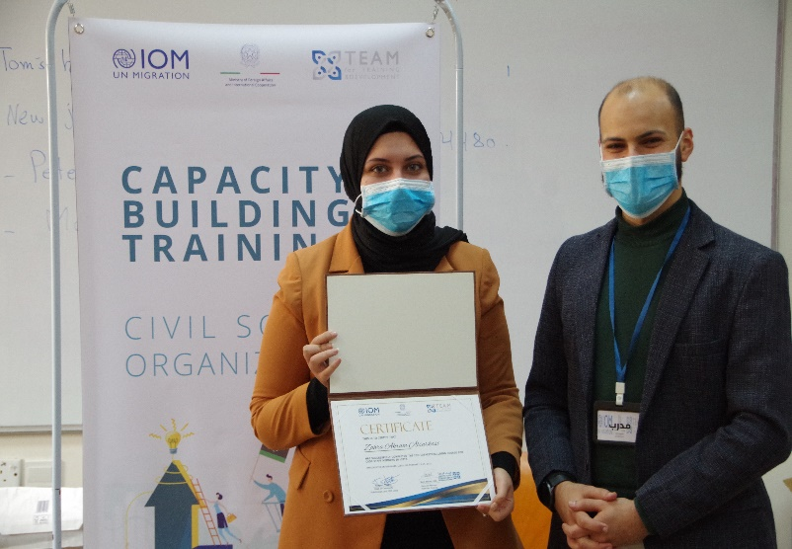
The capacity building initiative targeting members of local civil society organizations (CSOs) in {OMISSIS}, {OMISSIS} and {OMISSIS} was successfully completed. In total, 58 participants were involved, coming from more than 20 different grassroots organizations. Each group attended a 10-day (50 hours) professional training curriculum covering a range of topics such as the basics of project management, proposal writing, budget management, conflict sensitivity in line with the humanitarian ‘do no harm’ principle, and gender awareness. More than 300 applications were received; selection was based on a variety of factors including their area of operation, age, and gender to ensure that at least 50 per cent of participants were women. The training course included practical exercises and the development of a project proposal. Group work between participants from different locations was encouraged to ensure knowledge exchange and peer to peer learning. An internal competition was held to select the best project proposal drafted during the course. Participants also received toolkits—one tablet for each participant and one video projector for the winning proposals that will be used by the whole organization— with the aim to provide continued learning opportunities, advancing their work and helping them in their daily tasks.

collaboration with Al Waha CSO. © IOM, (2022).
Feedback from participants was extremely positive: “I appreciate this opportunity. I had the chance to learn about humanitarian topics and to gain skills that will be very useful in my work. I was happy to meet with members of other organizations and get to know about their work,” said Abir, representing a Libyan organization from {OMISSIS}. The training’s impact was very positive with 92per cent of the overall participants (58 – 26 women and 32 men)- demonstrating learning progress in the post-test rates. All participants indicated that they were satisfied with the training program and learning outcomes. Participants particularly appreciated the interactive learning methodology applied during the training and the possibility to develop a concept note using the IOM Implementing Partners template. The overall rate of correct answers in post test results reached 84per cent and each participant had the possibility to go through the test with the trainer during the last day to discuss mistakes. A completed report of the training including the programme, description, pre and post-test, evaluation training analysis and feedback from participants is available in Annex 5-. Below are two infographics summarizing the results of the satisfaction survey conducted after the training completion.
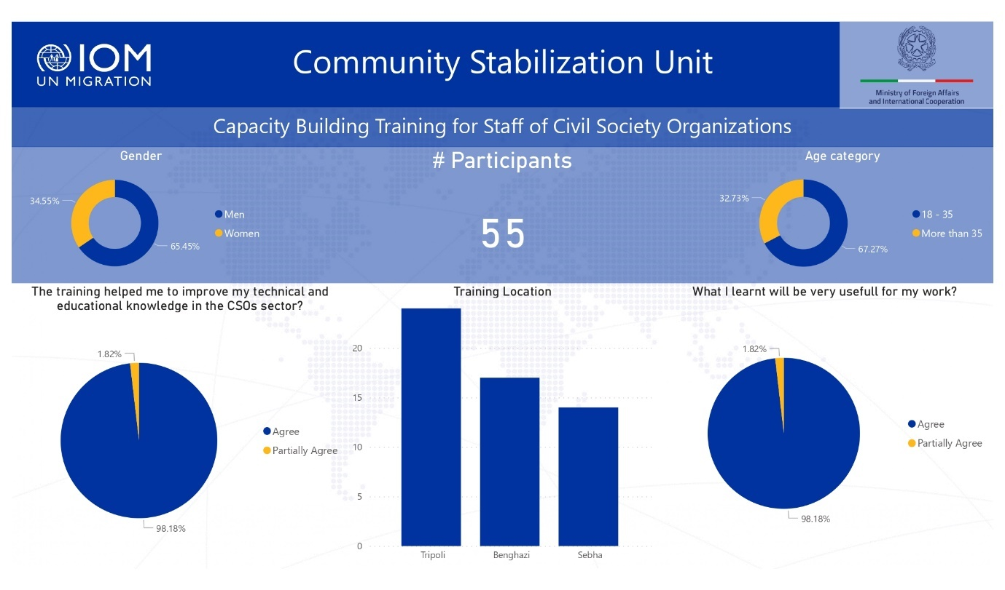
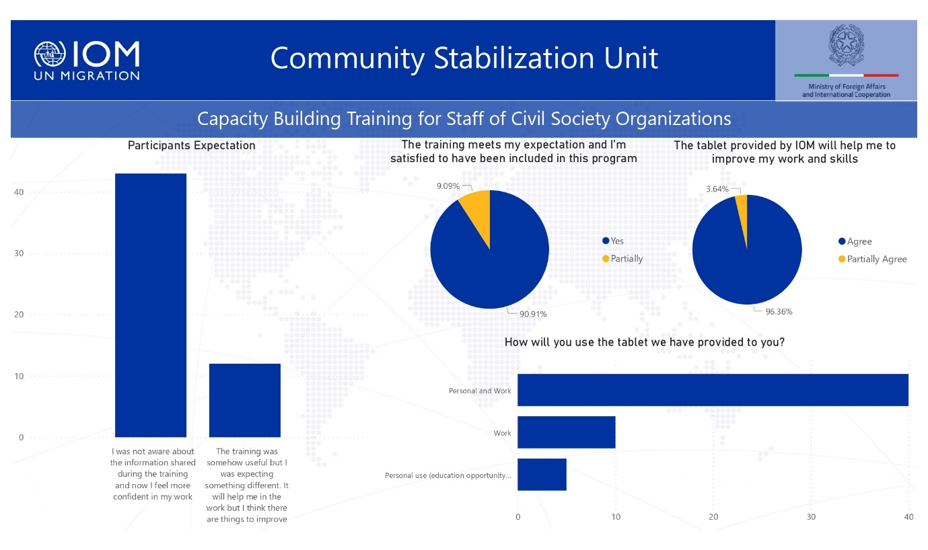

Outcome 2: Crisis-affected community members have improved access to basic services and community infrastructure
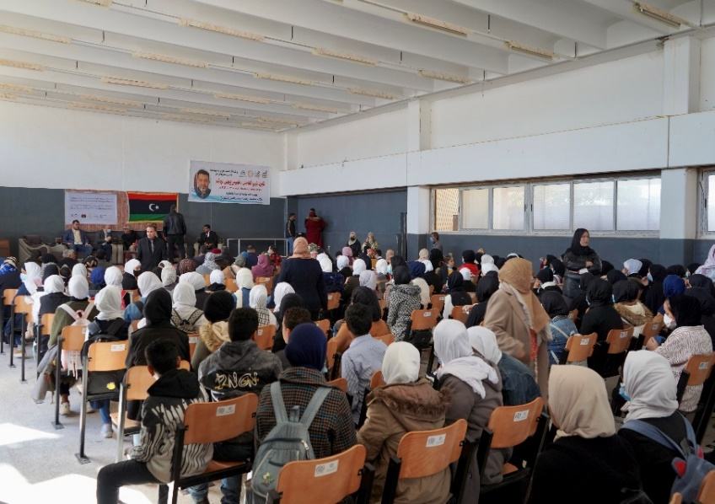
Under this outcome, IOM aimed to strengthen the effectiveness of local authorities by providing essential services to the community and to build trust within local communities by rehabilitating and improving essential infrastructure, such as water and sewage systems, as well as schools, hospitals and public spaces. IOM also provides equipment, such as furniture for schools, medical equipment and generators for clinics, pumps for the water and wastewater companies, and equipment to municipal staff to improve their services. Projects are called Community Improvement Projects (CIPs) and are identified through a consultative process with local communities to engage and strengthen local capacity and foster ownership and commitment to ongoing management of rehabilitated facilities. With this outcome, IOM aims to contribute to long-term stability by reducing tension associated with inadequate access to public services, and competition over resources.
Picture: Benghazi, February— Handover organized to deliver the equipment to Bodressa school. © IOM, (2022).

collaboration with Al Waha CSO. © IOM, (2022).
In total, 14 CIPs were completed and are fully functional. In {OMISSIS}, two educational projects were implemented: the provision of equipment for {OMISSIS} and {OMISSIS} primary and intermediate schools. Both educational projects served to increase educational opportunities and provide a healthy environment to students.

In {OMISSIS}, seven (7) CIPs were completed following the recommendation of the community consultations with approximately 200 people in six muhallas of {OMISSIS}, conducted between April to August 2021. Many residents felt that essential services provided by local government or official service providers were insufficient. Therefore the implemented projects prioritized the water sector by providing power generators to three water wells (3 CIPs), the health sector with provision of a generator to the physiotherapy centre in Qatroun (1 CIP) and the public sector by providing equipment to Al {OMISSIS}, {OMISSIS} Guest Houses and the Labor Office in Qatroun (3 CIPs).
In {OMISSIS} municipality, two CIPs were implemented with the provision of equipment to the municipality and to the Guest House. Tegheri is located in the South- West of Libya close to the Chad
{OMISSIS} border, 70 km from Qatroun, and is inhabited by around 4000 people mainly from Tebu tribes. It has been recently recognized as an independent municipality and lacks basic services including water, electricity, health services and paved roads. In {OMISSIS}, through an intervention aimed to strengthen the education sector, as requested by the local community, three CIPs were completed– the provision of equipment to {OMISSIS} Secondary School and {OMISSIS} School and to the {OMISSIS} Department.
Picture: {OMISSIS}, October— The speech made by a member of the municipality during the handover of {OMISSIS} GH. © IOM, 2021

collaboration with Al Waha CSO. © IOM, (2022).
A comprehensive description of the CIPs implemented with pictures is available in Annex 6– Description of Community Improvement Projects (CIPs). To ensure appropriate implementation and monitoring of infrastructure projects, IOM set up a structure of local field staff in project locations, most importantly national operation assistants and field engineers. As a first step, following community suggestions, a concept note was developed for each CIP to collect information on specific needs to be addressed, the rehabilitation work and equipment required, the possible impact and the number of beneficiaries that would be reached. Through a public tender process, IOM assigned the grants for the CIPs to domestic vendors that were continuously monitored by field monitoring staff. At the completion of the work, IOM ensured that procured items were delivered in working condition and were functional. An event was organized to handover the project to local communities and authorities.
Furthermore, after a minimum of one month upon completion of the infrastructure/rehabilitation/equipment grant, IOM is conducting outcome assessment visits to each site aimed to:
- Reviewing the achievements and impact of the grant in line with intended objectives and broader outcomes, recording successes and challenges.
- Identifying urgent issues, if any, thereby enabling immediate follow-up and closing feedback loops with communities
- Collect data to report against related to logframe indicators
- Complying with commitments laid out under Accountability to Affected Populations framework, including:
- Communities can expect delivery of improved assistance as organizations learn from experience and reflection.
- Communities have access to safe and responsive mechanisms to handle complaints

The complete survey analysis is available in Annex 7. Below are some infographics and narrative information provided as results overview. The outcome survey was conducted from January to April 2022 and in total, 84 people were interviewed during the outcome assessment visits. For each CIP, six beneficiaries were identified for the interview (two community members/inhabitant, a local authorities/municipal staff, a staff of the facility, a CSO representative, a tribal/elder leader of the area). The satisfaction survey has been developed and designed on KOBO and is composed of 47 questions divided in four categories: i) general information, ii) the situation of the facility before the rehabilitation/equipment, iii) the situation of the facility after the intervention and the impact of inhabitant’s life, iv) contribution to social cohesion, trust and wellbeing. All the questions can be consulted at the above KOBO link Survey.
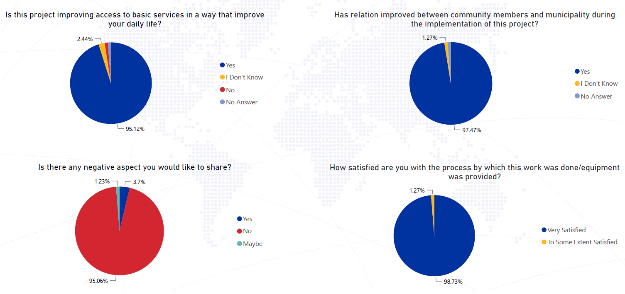

Among respondents, 95per cent reported that following the intervention, the condition of people living in the area addressed by the CIP’s had improved and inhabitants were very satisfied with the project. Also, 98.7per cent of beneficiaries reported that they were satisfied with the process (transparency, efficiency, communication) by which the work was completed, including that the project has helped in creating a more peaceful environment between community members. 97.4per cent of respondents reported that the implementation contributed to improved relations between community members and local authorities. Additional information on the impact was collected with open-ended questions to the beneficiaries. Below are some examples:
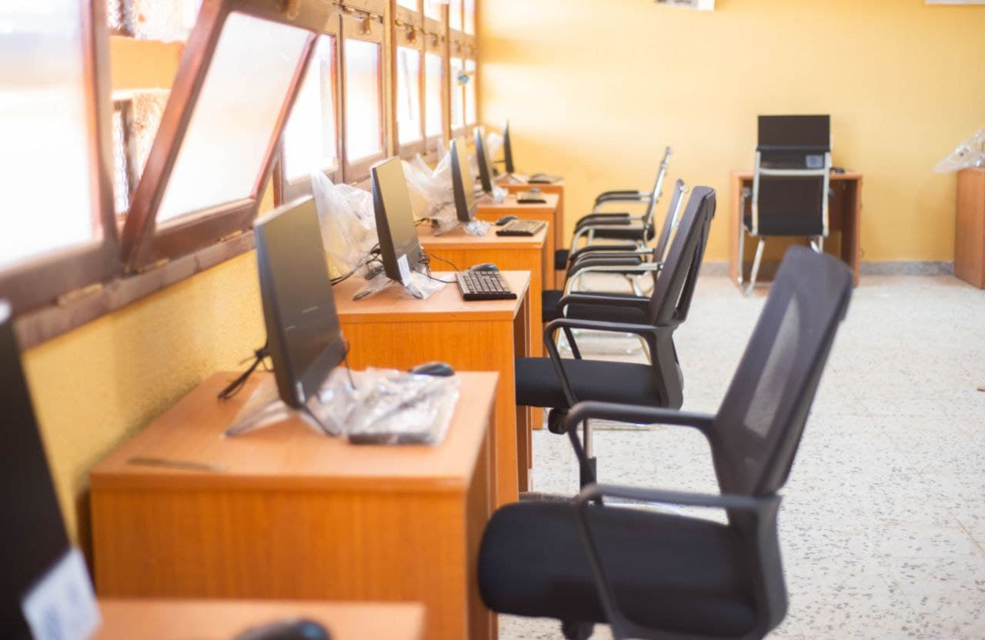
Regarding the three education sector CIP’s conducted in {OMISSIS}, one staff member from the education department said: “The improvement in productivity and wellbeing of our employees after the intervention will have an impact on the schools in {OMISSIS} and on the inhabitants of the city.” Furthermore, a teacher from {OMISSIS} School said: “With the new IT equipment provided to the school and the furniture to the theatre space, students can further expand their horizons and be involved in important activities for their future”. All {OMISSIS} respondents agreed that the community needed more of these types of projects since many schools in Ubari were severely damaged during the armed conflict that took place in 2014 which led to substantial challenges in the education sector due to building damage and loss of critical school equipment. {OMISSIS}’s Mayor, {OMISSIS}, during the handover ceremony said: "We’re putting all of our efforts to rebuild and improve the education sector in {OMISSIS}. Schools play a key role for the future of our children and this project is a sign of hope for all the community. I’m very happy that now students have access to a computer laboratory where they can develop new skills.”
Picture: {OMISSIS}, February— A computer lab was provided to {OMISSIS} Secondary School and {OMISSIS} School. @IOM 2022

collaboration with Al Waha CSO. © IOM, (2022).
The impact of the three projects that provided equipment to Guest Houses (GH) in {OMISSIS} area – including one in the new municipality of {OMISSIS} was also very positive. Approximately 80per cent of respondents mentioned that the facilities were in very poor condition before IOM’s intervention, especially {OMISSIS} GH that was closed due to the lack of essential equipment and items such as air conditioners, fans, fridges, rugs and mattresses. After IOM’s intervention, 100per cent of respondents reported that the GH’s are now fully functional and can be used free of charge by the community, including youth and migrants. The provision of items and equipment has 100per cent improved the life of inhabitants of the area – 100per cent of respondents reported - having a comfortable place to gather and hold social occasions. The space is now equipped to hold social activities for youth and for regular community meetings. An inhabitant of {OMISSIS} said during the ceremony “This is the only guest house in the area, and it is also serving neighbouring muhallas. It was in very bad conditions with lack of a generator, air-conditioners and mattresses on the floor where traditionally meetings take place; now, with the equipment provided by IOM we’ll be able to restart public events and ceremonies”.
CIP’s that ensure a constant access to electricity by providing a power generator to three water wells and the physiotherapy centre in {OMISSIS} led to 100per cent of survey’s participants reporting that access to electricity is now improved leading to a positive impact on beneficiaries’ daily life. For example, regarding the physiotherapy centre in {OMISSIS}, the only one in the city, two inhabitants said that before the intervention, patients could not follow treatment sessions regularly as the centre was closed during power cuts and people were obliged to move to {OMISSIS} – more than 200 km away – for their treatments and medical checks. Thanks to the new generator, the centre is now fully functional.

COMPONENT II: DIRECT ASSISTANCE
Outcome 3: Migrants, IDPs and where relevant host communities have increased access to humanitarian direct assistance

Direct Assistance to migrants in Detentions and Urban settings
Under the Direct Assistance component by the end of February 2022, IOM has assisted a total of 8,429 individual migrants (6699 men, 721 women, and 1,009 children) both in detention centres and urban settings with the provision of Non-Food Items (NFIs). Items that were distributed and received by beneficiaries include winter and summer blankets, winter and summer clothes, mattresses, individual hygiene kits.

Age and sex disaggregated data of migrants reached with direct assistance per location.

Area Of Distribution | Mantika | Distribution Date | Beneficiary Number | Male | Female | Children
{OMISSIS} Village | {OMISSIS} | 2/26/2022 | 261 | 137 | 87 | 37
{OMISSIS} City | {OMISSIS} | 2/25/2022 | 522 | 202 | 234 | 86
{OMISSIS} DC | {OMISSIS} | 2/24/2022 | 56 | 55 | 0 | 1
{OMISSIS} DC | {OMISSIS} | 2/23/2022 | 31 | 30 | 0 | 1
{OMISSIS} DC | {OMISSIS} | 2/23/2022 | 32 | 32 | 0 | 0
{OMISSIS} DC | {OMISSIS} | 2/16/2022 | 370 | 370 | 0 | 0
{OMISSIS} Shelter | {OMISSIS} | 2/13/2022 | 360 | 312 | 0 | 48
{OMISSIS} city | {OMISSIS} | 1/27/2022 | 191 | 83 | 66 | 42
{OMISSIS} DC | {OMISSIS} | 1/20/2022 | 650 | 634 | 0 | 16
{OMISSIS} Embassy | {OMISSIS} | 1/6/2022 | 37 | 31 | 1 | 5
{OMISSIS} DC | {OMISSIS} | 10/21/2021 | 57 | 54 | 2 | 1
{OMISSIS} DC | {OMISSIS} | 10/18/2021 | 550 | 501 | 0 | 49
{OMISSIS} DC | {OMISSIS} | 10/17/2021 | 916 | 703 | 16 | 197
{OMISSIS} DC | {OMISSIS} | 10/10/2021 | 68 | 57 | 0 | 11
{OMISSIS} DC | {OMISSIS} | 10/3/2021 | 900 | 819 | 0 | 81
{OMISSIS} DC | {OMISSIS} | 9/4/2021 | 176 | 124 | 23 | 29
{OMISSIS} DC | {OMISSIS} | 8/2/2021 | 65 | 61 | 4 | 0
{OMISSIS} DC | {OMISSIS} | 8/10/2021 | 26 | 13 | 5 | 8
{OMISSIS} DC | {OMISSIS} | 8/17/2021 | 71 | 0 | 56 | 15
{OMISSIS} DC | {OMISSIS} | 8/18/2021 | 348 | 195 | 75 | 78
{OMISSIS} Area | {OMISSIS} | 8/26/2021 | 1457 | 1088 | 101 | 268
{OMISSIS} City | {OMISSIS} | 8/26/2021 | 140 | 112 | 28 | 0
{OMISSIS} DC | {OMISSIS} | 8/29/2021 | 600 | 600 | 0 | 0
{OMISSIS} , {OMISSIS} and {OMISSIS} | {OMISSIS} | 8/30/2021 | 120 | 61 | 23 | 36
{OMISSIS} DC | {OMISSIS} | 8/31/2021 | 425 | 425 | 0 | 0
Total |  |  | 8429 | 6699 | 721 | 1009

Out of the total beneficiaries assisted under direct assistance, 5,341 migrants were reached in a total of 10 official detention centres run by DCIM whereas 3,088 migrants were reached in eight urban settings whose needs were identified through referral, outreach and regular DTM team assessments in the {OMISSIS} , {OMISSIS} , {OMISSIS} and {OMISSIS} to mention a few.

Direct Assistance to Internally Displaced Persons (IDPs)
Under this component, in addition to migrants, IOM has also assisted a total a total of 15,404 (4,323 men, 4,534 women, and 6,547 children) conflict affected and displaced Libyans in various part of the country. Assistance provided include blankets, mattresses, kitchen sets, tarpaulins, solar lamps, jerry cans, and hygiene kits that were designed to meet an average family size of five individuals. A total of 16 distributions were organized in a total of eight mantikas of Libya that were affected by conflicts and displacement. Some of these locations were hard to reach due to insecurity during times of distributions.

Date | Mantika | Location Name | M | F | <18 | Total | HH
16/11/2020 | {OMISSIS} | {OMISSIS} City | 628 | 496 | 1033 | 2157 | 406
18/11/2020 | {OMISSIS} | {OMISSIS} | 48 | 58 | 73 | 179 | 36
14/1/2021 | {OMISSIS} | {OMISSIS} City | 281 | 249 | 439 | 969 | 178
18/1/2021 | {OMISSIS} | {OMISSIS} City | 131 | 120 | 196 | 447 | 83
1/31/2021 | {OMISSIS} | {OMISSIS} | 553 | 553 | 843 | 1949 | 373
3/7/2021 | {OMISSIS} | {OMISSIS} City | 64 | 68 | 141 | 273 | 50
3/8/2021 | {OMISSIS} | {OMISSIS} City | 66 | 60 | 141 | 267 | 47
5/5/2021 | {OMISSIS} | {OMISSIS} City | 347 | 324 | 516 | 1187 | 194
5/6/2021 | {OMISSIS} | {OMISSIS} City | 173 | 160 | 291 | 624 | 87
5/8/2021 | {OMISSIS} | {OMISSIS} City | 269 | 248 | 446 | 963 | 161
5/10/2021 | {OMISSIS} | {OMISSIS} City | 131 | 123 | 225 | 479 | 69
5/21/2021 | {OMISSIS} | {OMISSIS} Area | 460 | 474 | 584 | 1518 | 314
5/24/2021 | {OMISSIS} | {OMISSIS} City | 106 | 99 | 367 | 572 | 90
5/25/2021 | {OMISSIS} | {OMISSIS} village | 29 | 20 | 51 | 100 | 26
6/21/2021 | {OMISSIS} | {OMISSIS} municipality | 428 | 545 | 733 | 1706 | 368
7/10/2021 | {OMISSIS} | {OMISSIS} City | 609 | 937 | 468 | 2014 | 400
Total |  |  | 4323 | 4534 | 6547 | 15404 | 2882

The NFI kits provided were designed to meet the different needs of men, women, boys, and girls; the personal hygiene kits were composed of hygiene and sanitation as well as dignity kits for men, women, and children. In addition, IOM has considered the seasonal weather conditions and needs of migrants when procuring and distributed the NFI kits and provided winter/summer blankets and winter/summer clothing along with other items depending on the season.

The standardization of the NFI kits considered the different needs of family members including men and women. For instance, the family hygiene kits were composed of hygiene and sanitation as well as dignity kits for men, women, and children. The quantity of the items was also designed to meet the average of family size of five members and in accordance with the Libya Shelter and NFI sector guidelines

Geographical distribution of beneficiaries

A large proportion of migrants assisted were found in {OMISSIS} {OMISSIS} reflecting the existence of many detention centers in {OMISSIS} whereas for IDP the large proprotion of them were found in {OMISSIS} also reflecting the high number of IDPs that were displaced from {OMISSIS} , especially towards the end of 2020.

Assisted IDPs and Migrants per Location
IOM’s Direct Assistance packages were designed based on the Shelter NFI Sector guidelines and the delivery of assistance were coordinated with the Shelter NFI and WASH for NFI and hygiene kits respectively while also the planning and distributions were organized in close collaboration with Crisis Committee, Ministry of IDPs and relevant Municipalities in the cases of assistance targeted IDPs and with {OMISSIS} and relevant Detention Centres in the cases of assistance to migrants. In addition, in several assistance coordinated for acute emergencies such as flood and conflict induced displacements, IOM collaborated with the Rapid Response Mechanism (RRM) members including {OMISSIS} , {OMISSIS} and {OMISSIS} to provide integrated and multi-sectoral assistance to displaced families. For instance, a total of 442 displaced households (2,336 individuals) 676 male, 554 female and 1106 children in Albayda and Albaraq cities were assisted through the RRM with joint NFI, Food, WAs and dignity kits support to flood affected and displaced families.

As part of measuring the quality of assistance and the satisfaction of beneficiaries, IOM conducted a PDM survey selecting a sample of 401 respondents. 348 confirmed that they would recommend IOM’s services to relatives and family. The data analysis also showed that 350 participants would approach IOM again for similar assistance, and overall 78 percent of the respondents reported to have been satisfied with the items. In terms of quality of items 52 per cent of beneficiaries said that the items received were reasonable, 42 per cent said they were good and almost 6 per cent of the beneficiary’s expressed disappointment with the items and said the quality was poor. Annexes 8 and 9 go into further detail on beneficiary satisfaction.

COMPONENT III: MIGRANT RESOURCE AND RESPONSE MECHANISM (MRRM)
This project was instrumental in allowing IOM to scale up MRRM intervention in two locations – {OMISSIS} and {OMISSIS}
During the project period MRRM field teams in Zwara and Bani Waleed reached total of 30,146 migrants (21111 men and boys and 9,035 women and girls) from 39 different nationalities, mainly from Sudan (7,833 migrants), Chad (5,931 migrants), Niger (5,109 migrants), and living in different localities of {OMISSIS} and {OMISSIS} municipalities.
Direct assistance Among the 12,856 migrants reached, including 2,000 HHs, almost 85per cent of which were female headed households, received a total of 16,412 non-food items. The NFI assistance provided included: hygiene kits, summer and winter clothing kits, mattresses, winter and summer blankets, tarpaulins, solar lamps, kitchen sets, sanitary pads and diapers. The following graph summarizes the quantity of each non-food item distributed during the reporting period.
{OMISSIS}

Image: The migrant Resource and Response Mechanism team in {OMISSIS} distributing crucial assistance to a widowed mother and her child. The assistance consisted of winter blankets, hygiene kits, children’s clothing kits, and Adults clothing. IOM/2022

Due to the increased need for food assistance requested by migrants, MRRM procured food kits that contained: 1 Kg white flour, 1 kg Pasta, 1 kg Rice, 2 x 400 g canned Chickpeas, 3 x 400 g canned red beans, 3 x 400 g canned Green peas, 3 x 400 g canned beans, 1 Liter bottle veg oil, 2 x 400 g canned tomato paste, 5 x 160 g canned Tuna, 0.5 Kg Sugar pack, 0.5 Kg Halawa pack, tea 2 packets of 100 teabags, 0.5 kg salt and 1 packet date biscuit (mini bars) 25 g/bar. Food assistance remains a priority humanitarian need for migrants. The distribution of food kits supported the targeted beneficiaries to cover their food and nutrition needs, contributed to the improvement of their health and living conditions, and helped migrants to allocate resources towards meeting other basic living needs.
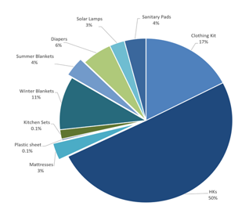
Most of the assistance provided took place in urban settings and through door-to-door activities. As part of IOM’s do-no-harm approach, MRRM teams have supported 22 Libyans (15 men and boys, 7 women and girls) living in the same area as migrants with NFIs, through providing hygiene kits and healthcare services based on the need.
During the project period, the MRRM teams conducted outreach in different locations inside {OMISSIS} and {OMISSIS} municipalities and the neighbouring districts, among them {OMISSIS} (20 km), {OMISSIS} (25 km), {OMISSIS} (60 km), and {OMISSIS} (80 km) from {OMISSIS} . While {OMISSIS} reached {OMISSIS} Valley (25 km), {OMISSIS} new farms (65 km), {OMISSIS} (43 km), {OMISSIS} (13 km).
Image: Percentages of non-food items distributed in {OMISSIS} and {OMISSIS}

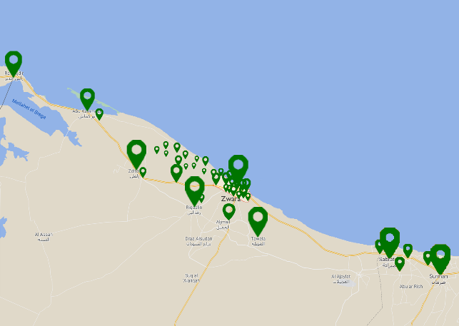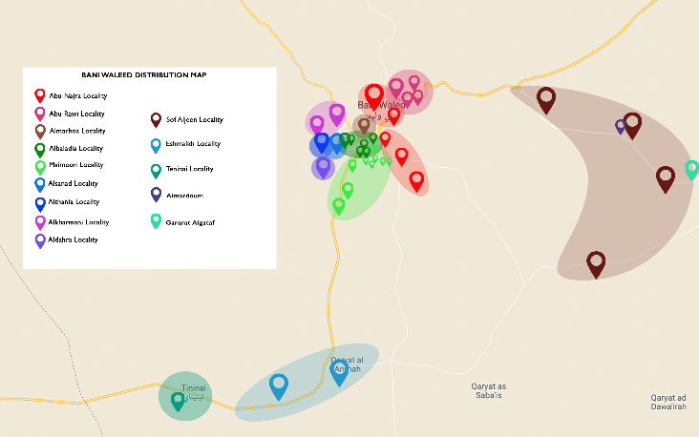
Images: MRRM distribution maps; Zwara and Bani Waleed

In addition, to ensure IOM’s response to the migrants in need, MRRM team in {OMISSIS} conducted regular meetings with the Libyan Red Crescent (LRC) and Crisis Committee to address common challenges faced. In February 2022, the team collaborated with LRC and donated 19 mattresses to be used for any referred emergency or vulnerable cases from host community and migrants to LRC. As well, MRRM team in {OMISSIS} organized several meetings with safe house local organization, and community leaders of migrant communities residing in {OMISSIS} , including Nigerien, Chadian, Indian, and Sudanese community leaders.

The MRRM teams continued to maintain these contacts through regular communication and provided information about available MRRM services and updates about planned activities. MRRM teams in {OMISSIS} and {OMISSIS} have referred 330 cases to other units in IOM including 14 cases that were referred to protection unit, the referred cases were vulnerable women, persons at risk, child protection and GBV cases, two cases were referred to Mental Health and Psychosocial Support (MHPSS) unit, and 314 cases were referred to Volunteer Humanitarian Return (VHR) unit.
The low number of referrals to VHR operations during 2021 was due to long delays in operation which was outside of IOM’s control which affected the migrants’ decision, and many have lost confidence to register for VHR programme due to the long waiting time during that period. VHR flights were suspended at DCIM’s request due to ongoing internal political challenges. Nevertheless, when the flights resumed, IOM VHR team collaborated with MRRM team in {OMISSIS} and conducted regular visits to MRRM base in {OMISSIS} to follow up on the outreach to potential VHR cases in the city. On the other side, MRRM {OMISSIS} team collaborated with MHPSS and established an integrated outreach weekly plan to follow up on potential MHPSS cases, thus the MHPSS case worker has been directly screening the targeted cases while joining MRRM team 3 days a week. Hence, the number of referred cases is lower than the set target at the beginning of the project period.

Location | VHR | Protection | MHPSS
{OMISSIS} | 98 | 0 | 0
{OMISSIS} | 216 | 14 | 2
Total | 314 | 14 | 2
Number of Cases Referred to other IOM Units

In June of 2021, a series of xenophobic incidents ignited in {OMISSIS}. Migrants were physically attacked, many expelled from their homes, and they had to restrict their movement to avoid clashes. The MRRM team leader conducted a meeting with the Mayor of {OMISSIS} Municipality to discuss the situation and possible actions to ensure migrants’ safety. IOM continued to provide assistance and services to reduce possible risks as much as possible and sent monitoring reports and referrals to relevant partners. IOM during this reporting period continued to maintain contact with affected communities via outreach and monitoring visits by IOM case workers working in the area and the IOM hotline services. The MRRM team supported 130 migrants who encountered violent behaviour in the {OMISSIS} old city. The majority of migrants were from Liberia, Nigeria, Ethiopia, Eritrea, and new arrivals from Sudan. Based on the identified needs, migrants received NFIs, food, medical assistance, and referral services, including referrals to {OMISSIS}.

Awareness raising

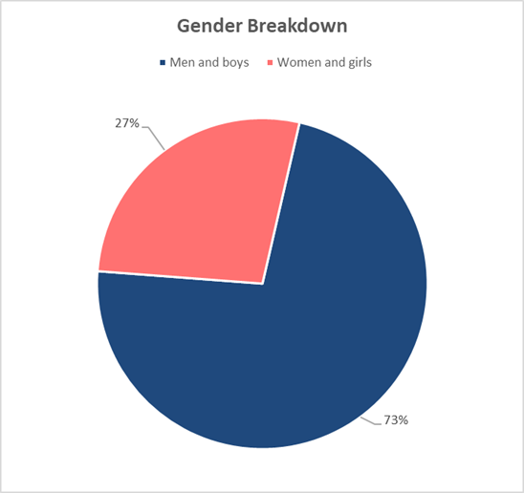
Within the project period 11,566 migrants (8,396 men and boys, 3,170 women and girls) were reached during a total of 1,138 awareness raising sessions. The awareness raising information capitalized on the materials developed under the #InformedMigrants campaign. Supporting Information, Educational, and Communication (IEC) materials were printed in Arabic, French, and English, and distributed during the sessions. MRRM teams distributed 6,364 pocket guides and 3,470 helpline cards.

Image: Gender Breakdown of Awareness Sessions Attendees

During the project period, as part of the activities to promote awareness raising information, MRRM teams in {OMISSIS} and {OMISSIS} celebrated the World Day of Cultural Diversity on 21st May 2020. The teams conducted awareness raising sessions and art-based activities. In Bani Waleed, 14 migrants from Chad, Sudan, Palestine, Algeria, Mali, and Nigeria attend this session. While 11 migrants from Nigeria and Liberia attended the session in {OMISSIS} .
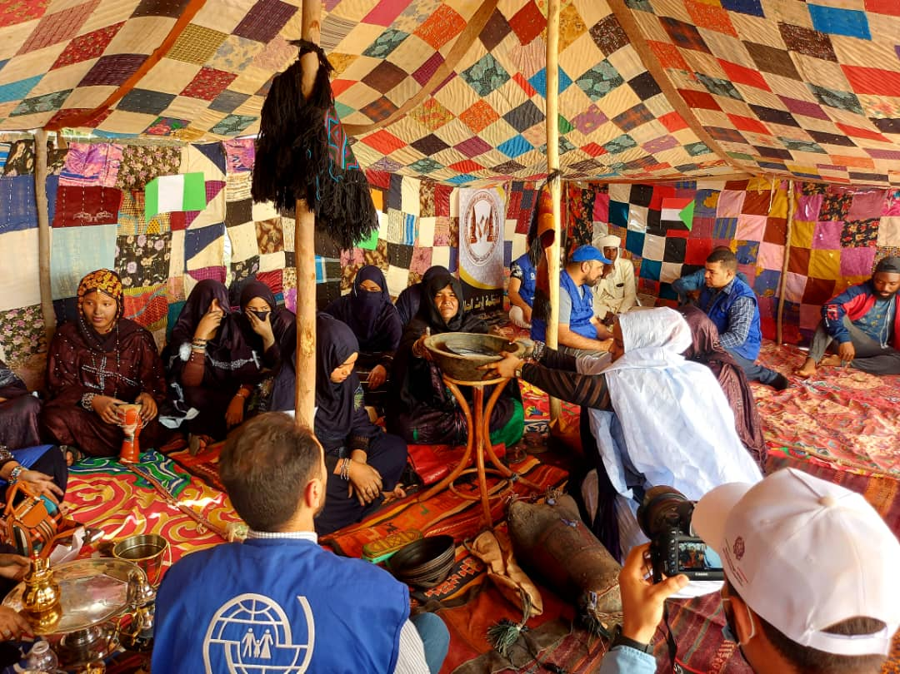
Image: World Cultural Diversity Day activities held in {OMISSIS} . IOM 2022

In January 2022, as part of the activities to raise awareness on the risks of irregular migration and to promote the IOM helpline number in {OMISSIS} , MRRM team painted an awareness raising mural at the Safe House Organization- a local organisation, that works with migrants and provides shelter in {OMISSIS} . Two Libya woman artists were contracted to work on the mural; the artwork focuses on promoting the IOM helpline number while ensuring that the illustration style is positive and representative of the migrant communities in the area. The artwork was shared with the Safe House Organization and migrant focal points for their review and endorsement. On the implementation day, 31 male migrants were at the Safe House Organization while the artists were preparing the wall for the murals. The MRRM team implemented an awareness raising session discussing the risks of irregular migration and sharing information about the IOM services available for migrants. After the session, migrants joined the artists and took part in painting the mural.

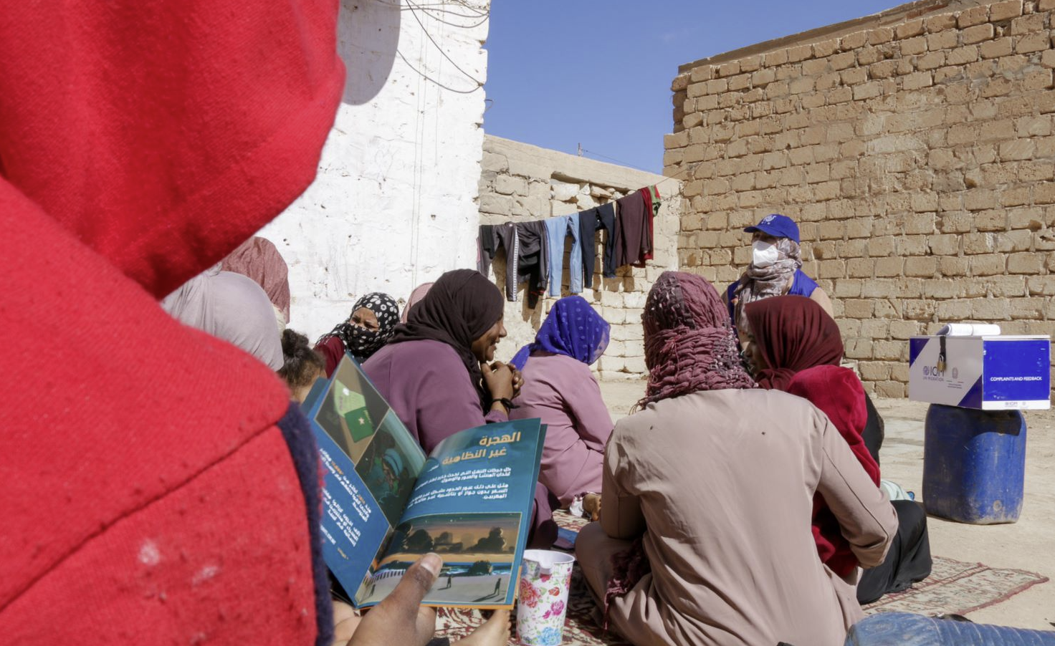
The migrant Resource and Response Mechanism team conducting an awareness session about the dangers of irregular migration to chadian nationals. IOM/2022
In addition, MRRM team in {OMISSIS} celebrated the International Migrants Day in MRRM base in {OMISSIS} on 18 December 2020. The team conducted awareness raising sessions in addition to several recreational activities such as a film screening for children and psychosocial group session for 28 migrants, including 16 children from Sudan, Chad, Gambia, Nigeria and Yemen. The team alternate between Arabic and English as per the native language of the participants.
{OMISSIS}
Image: Awareness Raising Mural Implemented at {OMISSIS} , © IOM (2022).

During the project period, as part of the monitoring of activities in the field and the capacity building of the staff, MRRM arranged for a monitoring visit to {OMISSIS} to support the field team and implement an Accountability to Affected Population (AAP) training session for migrant community leaders and staff. The team conducted rehearsal session for case workers on how to implement awareness raising sessions to ensure the quality of information and facilitation style is consistent. The team also received a refresher session on how to collect human interest stories. This refresher was conducted in order to enhance visibility and reporting.
Additionally, MRRM teams received online capacity building session on Communication for Development (C4D) and how it can be applied during awareness raising and outreach activities, and a refresh session on the humanitarian principles and response to affected population needs.
IOM’s approach to outreach and distribution through MRRM mobile teams helped to minimize the safety risks faced by vulnerable migrants especially those affected by food insecurity, lack of non-food items and limited access to health services. For example, food and non-food items were delivered directly to migrants at fixed locations and through door-to-door assistance, reaching individuals in urban and remote locations who had limited access to markets. Home visits to target households were a means of accessing vulnerable persons who were unable to access public sites, given that women and children have been increasingly confined indoors since the advent of the COVID-19 crisis. The project has assisted IOM to maintain and expand MRRM services, with food assistance reaching widows, female-headed households, people with disabilities, elderly, and survivors of people smuggling.
Protection
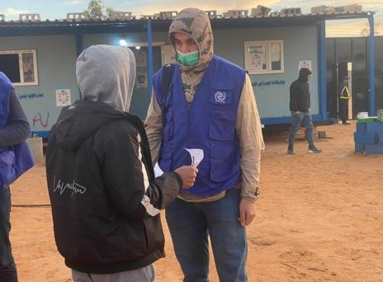
During the course of the project, IOM Protection team reached and provided specialized protection assistance to 135 migrants (47 women, 42 men, 27 boys and 19 girls). The team conducted 71 (9 women, 16 men, 27 boys and 19 girls) rapid screenings and 64 (38 females and 26 males) detailed vulnerability assessments. This included the identification of and service provision to survivors of abuse, torture or trafficking in persons and children at risk. Moreover, among the identified and assisted migrants, two migrants (one man and woman) were referred internally to IOM’s MHPSS team to receive the assistances.
IOM Protection team maintained continuous provision of services in urban areas through its community-based protection teams to help identify evolving needs and vulnerabilities in the community and to ensure that migrants requiring specialized support were able to access the needed assistance at their locale. 29 Outreach and monitoring visits continued to take place in urban settings in {OMISSIS} and {OMISSIS} and four detention centers in {OMISSIS} : {OMISSIS} , {OMISSIS} {OMISSIS} and {OMISSIS} .
Image: IOM protection team carrying out follow up visits at {OMISSIS} detention center

Health
During the project period, two medical teams were recruited in {OMISSIS} and {OMISSIS} - consisting of a doctor and a nurse each - within the MRRM framework. The required equipment, medicines and supplies were procured. In addition, a functional and well-equipped clinic was established at the IOM-MRRM base in {OMISSIS}. The MRRM team leader prepared a weekly workplan in coordination with health unit and displacement tracking monitoring (DTM) unit and community leaders to identify outreach locations.
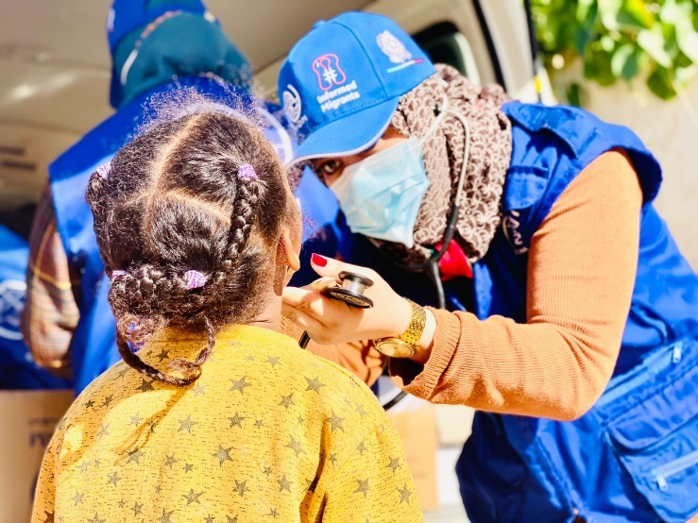
The medical team equipped with medications, medical dressing consumables, and medical examination tools joined the filed visits and examined migrants with medical conditions and provided medical consultations. Based on examination results, some screened migrants were provided with treatment on site, while some cases were referred for specialized treatment.
At the {OMISSIS} clinic, the medical doctor and nurse received migrants and provide medical assistance required, including medical consultations, surgical consultations, minor surgical management, regular dressings, health awareness and promotion, and referral to secondary and/or tertiary health centres. The clinic is provided with all the required medicines, consumables and supplies required to support the primary health care needs and are replenished on needs basis from MHD medical warehouse. Similarly, any additional equipment is added on need basis and out of order equipment is repaired or replaced to ensure continuity of services. In {OMISSIS} , the medical team, in coordination with the MRRM team conducted daily mobile outreach visits to different communities, equipped with required medications, consumables and supplies required for mobile primary health care.
Photo: Physician in {OMISSIS} providing a medical consultation to a migrant child.
Outreach medical visits
During reporting period, health consultations and assistance were provided to migrants 9549 in communities of {OMISSIS} and {OMISSIS} , out of total 6109 consultations were provided in {OMISSIS} community and 3440 consultations were provided in {OMISSIS} , (19.4per cent of medical consultations were provided to children under 18 years old, 21.5per cent were provided to women, 59 per cent were provided to men).
{OMISSIS}
Medical Visits for migrants - Urban Areas IOM
Month | Location | Number of beneficiaries |  |  |  |  |  |  |  | Total
 |  | Male |  |  |  | Female
 |  | 0-5 Y | 6-17 Y | 18-59 Y | 60+ Y | 0-5 Y | 6-17 Y | 18-59 Y | 60+ Y
Sep 2020 - Feb 2021 | {OMISSIS} Outreach | 8 | 21 | 162 | 2 | 9 | 4 | 68 | 7 | 281
 | {OMISSIS} Outreach | 18 | 10 | 101 | 5 | 13 | 9 | 51 | 2 | 209
March 2021- August 2021 | {OMISSIS} Outreach | 94 | 165 | 1514 | 50 | 135 | 84 | 506 | 35 | 2583
 | {OMISSIS} Outreach | 61 | 54 | 893 | 31 | 62 | 56 | 185 | 20 | 1362
Sept 2021- Feb 2022 | {OMISSIS} Outreach | 163 | 234 | 1836 | 31 | 146 | 89 | 705 | 41 | 3245
 | {OMISSIS} Outreach | 139 | 97 | 959 | 57 | 99 | 80 | 400 | 38 | 1869

Photo: IOM Provides critical access in {OMISSIS} to primary healthcare services to vulnerable migrants including women and children.

The most common health problems among migrants were dermatological diseases including large number of scabies cases, acute upper respiratory diseases musculoskeletal disorders and gastrointestinal diseases.
Referral to secondary and tertiary health centres:
During the project period, a significant number of cases were referred by {OMISSIS} and {OMISSIS} medical teams to secondary and tertiary health care facilities. A total of 567 referrals were completed, of which 345 were by the {OMISSIS} team and 222 referrals were completed by the {OMISSIS} team. Many of those referrals were urgent and lifesaving, including sick children, pregnant women for antenatal, natal and postnatal care, psychiatric cases, and GBV and rape survivors, as well as presumptive TB and COVID-19 cases for screening and management. The referrals were both for diagnostic purposes and inpatient care. In order to facilitate such referrals, IOM used its already established mechanism of agreements with hospitals and ambulance service, which ensured swift and smooth referrals and remained instrumental in preventing mortality and disabilities.

{OMISSIS} medical referrals
Project period | Number of beneficiaries |  |  |  |  |  |  |  | Total
 | Males |  |  |  | Females
 | 0-5 Y | 6-17 Y | 18-59 Y | 60+ Y | 0-5 Y | 6-17 Y | 18-59 Y | 60+ Y
Total period | 11 | 27 | 150 | 4 | 9 | 7 | 133 | 8 | 345
{OMISSIS} medical referrals
Project period | Number of beneficiaries |  |  |  |  |  |  |  | Total
 | Males |  |  |  | Females
 | 0-5 Y | 6-17 Y | 18-59 Y | 60+ Y | 0-5 Y | 6-17 Y | 18-59 Y | 60+ Y
Total period | 9 | 12 | 94 | 13 | 6 | 5 | 75 | 11 | 222

Multiple migrants and host communities were visited and provided with the integrated MRRM assistance including the medical assistance and support which played an important role in building strong bridges between IOM teams and migrants and host communities through the crucial interventions and quick responses to migrants’ health needs, migrants became very familiar with IOM support and wide community network was established between MRRM staff and migrants community leaders and migrants which facilitated the direct and indirect approach of migrants to IOM services.

COMPONENT IV: CAPACITY BUILDING
The purpose of capacity building components was to improve Libyan officials’ knowledge on human rights-based migration management. It aims to promote a comprehensive and effective governance of migration in Libya, by specifically targeting front line officers on migration management knowledge and procedures.

Outcome 5: Strengthened capacity of local authorities to address migrants’ needs
During the project period, four trainings were held and one workshop whereby a total of 82 (11 women, 71 men) officials were trained. The targeted number of 150 officials to be trained could not be achieved due to the impact of the COVID-19 pandemic and the related prohibition of gathering public events for an extensive period of time. To the extent possible, trainings were converted to a virtual setting by, shifting the face-to-face training to a remote training event by using video conferencing applications. The lack of suitable equipment and limitations experienced in the availability of a stable internet connection made it even more difficult to get government officials to connect to the online-training portal and actively participate in the training sessions. As soon as the Covid-19 restrictions allowed, another in-person event was organized by the end of 2021.
IOM supported two government officials(2 men) from the Ministry of Foreign Affairs to take part in an academic training course in International Migration Law, organized by the Institute of International Humanitarian Law (IIHL) of {OMISSIS} (7-17 November 2020 and 1-21 March 2021 respectively). The course focused on the international legal framework governing migration and its latest developments, and it is designed for government officials and others working in migration. It enhances participants’ skills to develop and apply policies and programmes in conformity with International Law and strengthens participants’ ability to contribute to the development of effective migration management systems.
Between 7-11 of March 2021, IOM conducted Humanitarian Border Management Training in coordination with IOM’s {OMISSIS} ({OMISSIS}) aimed to enhance the knowledge, skills and abilities of participants to better perform humanitarian border management tasks while acquiring specific professional skills and knowledge on international humanitarian law and human rights. The training adopted both virtual and in-person training methods whilst observing strict adherence to health and safety guidelines to prevent COVID-19 infections. The training was very successful, reaching 24 participants (18 men, 6 women) from eight different governmental entities, namely The Ministry of {OMISSIS} , Ministry of {OMISSIS} , Ministry of {OMISSIS} , Ministry of {OMISSIS} , {OMISSIS} Authority, Libyan {OMISSIS} , General Administration of {OMISSIS} {OMISSIS}, and the National Team Rapporteur. The five-day training was divided into nine sessions focused on: Migration Law, Emergency and Planning, Document Security, Identification and Biometric registration.
Between the 21-27th of March 2021, IOM conducted Migration Governance Training in {OMISSIS} (22 participants, 20 men, 2 women). The training programme was divided into six modules and the overall objective was to enhance the capacity of relevant Libyan national authorities to prepare for and address the needs of migrants, in the event of a crisis affecting the country. The training was composed of an interactive lecture session, group discussions and group exercises moderated by instructors from the American University in {OMISSIS} ({OMISSIS}) and the IOM thematic specialist for Immigration and Border Management. The training focused on various topics spanning from Migration and Development, International Migration Law, Trafficking and Smuggling of Migrants to Labour Migration, and an overview of the most recent updates on migration governance. Libyan Government officials reported to have enhanced their skills and knowledge in migration governance as a result.
The Migrants in Countries in Crisis (MICIC) training was held from 6-8th of April 2021 with the aim to enhance the capacity of relevant Libyan national authorities to prepare for and address the needs of migrants in the event of a crisis affecting the country. The training reached 20 participants (18 men, 2 women) from 13 governmental bodies, who gathered for a three-day training focused on the MICIC Initiative and Guidelines, Migrants’ Vulnerability and Capacities in Emergencies and Coordination for Improved Assistance to Migrants in Emergencies​.
The sessions presented the participants with guidelines to follow during and after a crisis, and shared best practices particularly relating to tracking information in conflicts, how to communicate effectively with migrants and establishing clear referral procedures among stakeholders. During this training, participants were able to discuss the establishment of a mechanism to share information that is relevant to preventing, preparing for, and responding to crises. In addition, the training enabled government officials to coordinate capacity building events on matters that are relevant to crisis management.
Since all three trainings took place in a mixed environment of physical presence and connecting via the use of video-conferencing tools, pre- and post-training assessments were collected, but replaced by a self-assessment tool, allowing them to measure the increase of knowledge on this subject by themselves. Nevertheless, the presented topics and the training events were even of greater importance in a time where the public and government entities were struggling with the impact of a worldwide pandemic, evidenced by a still high number of participants taking part in the trainings, despite the constraints pointed out above.
{OMISSIS}
Image: Disaster Risk Reduction (DRR) Workshop (29-30, November 2022) at {OMISSIS} , Libya
In November 2021, IOM organized a Disaster Risk Reduction (DRR) and Preparedness Capacity Workshop (29-30 November 2021) for national stakeholders in {OMISSIS} . The workshop supported the development of an effective disaster risk mitigation plan as well as adequate policies, with participants being further able to identify and mitigate the risks related to natural hazards and plan emergency responses in such events.
The workshop reached 14 Libyan officials (13 men,1 women) from seven governmental bodies; Ministry of {OMISSIS} (3), House of Representatives (1), Libyan {OMISSIS} Agency (1), Libyan {OMISSIS} (1), Municipalities (6), Ministry of {OMISSIS} (1), Ministry of {OMISSIS} (1). The workshop presented the participants with the key concepts of DRR, Sendai Framework, and guidelines to both structural and non-structural risk mitigation measures to be adopted. It empowered participants with the effective and successful preparedness, response, and recovery mechanisms to be followed upon occurrence of natural disaster, and shared the best practices and lesson learnt from other countries.
{OMISSIS}
Image: Disaster Risk Reduction (DRR) Workshop (29-30, November 2022) at {OMISSIS} , Libya
The workshop was completed with a simulation session, during which participants were able to reflect on the possible coordination mechanisms, preparedness, and response plan of a sudden flood. The participants rated the training as being ‘very satisfying’, useful and relevant for their field of work (see M&E Data Analysis report for DRR Workshop in annexes). Considering the increasing occurrence of natural disasters due to climate change and the overuse of natural water resources in an arid environment, the simulation session shared valuable first-hand experience and lessons learned in how governments and states are responding and handling natural disasters in other countries.

Progress Made towards Incorporating Cross-cutting Themes

Accountability to Affected Populations, Gender Mainstreaming, and Conflict Sensitivity

Since the commencement of the project, IOM actively engaged the community and local authorities in each step of the project to engage in the decision-making process for the benefit of the entire community. For example, under the CS activities regular meetings and events were conducted with community members and local authorities to ensure a regular update on activities implementation and feedback. All interventions have been conducted while ensuring that the needs of the most vulnerable are addressed. Youth and women empowerment is one of the IOM’s priority areas. For this reason, under the CS component specific projects focused to empower capacities of women and youth to engage with other community members and to act as agent of change in their community. Therefore, conflict sensitivity assessments are rigorously conducted to ensure that interventions will be context appropriate and contribute to address drivers of instability in a sustainable manner.

IOM’s approach to outreach and provision of assistance through MRRM mobile teams helped to minimise the safety risks faced by vulnerable migrants affected by the security situation, COVID-19 pandemic and its consequences including the food insecurity. For example, healthcare services, NFIs and food items were delivered directly to migrants at fixed locations, reaching individuals in urban and remote locations who had limited access to health facilities or to the markets. Home visits to target households were a means of accessing vulnerable persons who were unable to access public sites, given that women and children have been increasingly confined indoors due to COVID-19. The project has assisted IOM to maintain and expand MRRM services reaching widows, female-headed households, minors, people with disabilities, elderly, and survivors of people smuggling.
With regard to the provision of assistance directly to migrants, it should be noted that women are very much a minority within the migrant population in Libya being usually approximately 10 per cent and tending to be in a vulnerable position. Specific efforts were made to ensure that women and specifically female headed households, benefited from the available assistance. This was made possible through the engagement of community leaders and female migrants who act as focal points within their networks. Approximately 85 per cent of the households in {OMISSIS} and {OMISSIS} are female headed. The assistance IOM was able to provide supported them in surviving through their daily struggles in Libya.

IOM interventions are implemented in multiple locations with varying gender and cultural beliefs. In some locations, women are comfortable participating in mixed gender activities, such as meetings and decision-making processes, while in others, there is a general hesitation to include, or be included in mixed gender settings.
As part of an inclusive approach, incorporating the needs and wants of women, IOM has taken specific ways in which women’s voices have been included along the project timelines and across all outcomes. An example of this is during the organization of awareness sessions and in meetings with focal points where women were encouraged to attend and were extended invitations as representatives of their community during such activities. Women have been a vibrant component of the programme with their participation and engagement in the proposed activities.

For the CS component, IOM uses a community-driven approach to consult communities for the identification, selection, handover, and endorsement of the Community Improvement Projects. This process allowed IOM to get the consensus of all stakeholders and communities to decide which projects respond to their most urgent needs and through the handover of CIPs contributed to increase ownership of the projects. Through the CIPs, IOM addressed the lack of basic services and absence of social space for interaction and meanwhile working in coordination with local authorities and communities.

As part of IOM’s commitment to mainstream accountability, MRRM conducted a virtual capacity-building session on Accountability to Affected Populations (AAP) on 22 June 2021, explaining AAP as a concept and introducing available Complaint and Feedback Mechanisms (CFM) in Libya, and how MRRM teams can promote CFM among migrants. MRRM team leaders and case workers in {OMISSIS} , {OMISSIS} , {OMISSIS} , {OMISSIS} , {OMISSIS} , {OMISSIS} , and {OMISSIS} attended the session.
For the CB component, IOM actively sought to invite female participants for the trainings and ensured balanced gender representation for the speakers.

Progress Achieved Compared with the Indicators in the Results Matrix

 |  | Indicators |  | Baseline |  | Target | Data Source and Collection Method | Achieved During the Project Period
Objective:  Contribute to resilience of crisis-affected populations in Libya |  | % of beneficiaries (IDPs, migrants or host community) who report improvement in their lives as a result of the services/trainings received |  |  |  | 75% | Monitoring reports,  Satisfaction surveys | Direct Assistance:  78% of beneficiaries participated in NFI PDM reported to have been satisfied with IOM’s assistance  Community Stabilization: 95% reported of CIPs beneficiaries reported improvement in their daily life and access to service after IOM implementation.  94% of CSOs staff reported increased capacities after the training and ability to improve their performance at work.
Outcome 1:  Crisis-affected communities have enhanced social cohesion and capacities to address community issues |  | % of CSO participants report increased capacity to address community issues  % of participating community members who report improved perception of other tribes, migrants, IDPs and returnees in their community |  |  |  | 70%  70% | Survey among community members in the selected locations  Participants' feedback forms | 98% of CSO reported increased capacities to respond to community needs  90.9% of CSOs reported that skills and knowledge learned during the training will be useful for their daily work  For CIPs beneficiaries:  98.7% reported that intervention helped to create a positive atmosphere between community members  97.5% reported that relation improved between community members and municipality during/after project implementation.  For community engagement/capacity building and social cohesion activities:  96% of participating community members who report improved perception of other tribes, migrants, IDPs and returnees in their community (this data is an average between survey and training evaluation conducted during and after the scout activity, the CSOs capacity building training, the mediation and peacebuilding training for women implemented by {OMISSIS} NGO.)
Output 1.1:  Capacity of local CSOs is enhanced |  | # of CSOs capacitated  # of community members (IDPs, migrants or host community) who participated in community stabilization and cohesion promotion activities |  | 5 |  | 10  2000 | Project records  Project records | 25  1618 (892 men and 726 women) of community members (IDPs, migrants or host community) who participated in community stabilization and cohesion promotion activities
Outcome 2:  Crisis-affected community members have improved access to basic services and community infrastructure |  | % of the targeted community members indicating access to improved basic services and community infrastructure |  |  | 80% |  | Survey among community members in the selected locations | 95% of the targeted community members reported improved access to basic services after IOM implementation  94% of the of the targeted community members reported increased access to the facility rehabilitated/equipped  84% of the targeted community members reported that CIP intervention improved  the life of inhabitant of the area
Output 2.1:  Common infrastructures are rehabilitated to provide essential services |  | # of CIPs implemented  # of people benefiting from the CIPs | 29 |  | 10  10000 |  | Weekly progress reports  Field monitoring | 14  Approximately 40 000 of people benefiting from the CIPs
Outcome 3:  Migrants, IDPs and host communities, where relevant, have increased access to humanitarian direct assistance | % of beneficiaries who are satisfied with the received assistance |  |  |  | 70% |  | Survey | 78% satisfaction reported as per the NFI PDM
Output 3.1: DA  Migrants, IDPs and, where relevant host communities, received NFIs | # of families receiving full NFI kits |  |  |  | 2400 |  | Interviews, written feedback from CSOs, workshop attendance | 23,833 (11,022 male, 5,255 women and 7,556 children) individuals, from those 15,404 were IDPs and 8,429 were migrants,
Outcome 4: MRRM  Migrants have improved access to humanitarian assistance that improves their well-being | % of beneficiaries reporting satisfaction with MRRM services |  |  |  | 70% |  |  | 56.48% of respondents reporting to be satisfied with the assistance received and 35.16% reporting to be very satisfied. Giving a total of 91.64% of satisfied respondents. Data analysis enclosed as annex.
Output 4.1:  Migrants have access to integrated multisectoral assistance | # of primary healthcare consultations provided by IOM's health teams  # of referrals to secondary and tertiary health facilities  # of protection assessments and support provided  # of beneficiaries loose NFIs, hygiene items and basic food packages (disaggregated by sex)  # of referrals to VHR and other IOM or non-IOM programmes |  |  |  | 4,000  180  50  2,800  750 |  | Database records, reports, pictures  Database records, reports, pictures  Database records, reports, pictures  Database records, reports, pictures | 9549 primary healthcare consultations  567 referrals to secondary and tertiary health facilities  134 migrants (47 women 42 men and 19 girls) were reached. 71 ( 9 women, 16 men, 27 boys and 19 girls) rapid screenings, 64 ( 38 females and 26 males) detailed vulnerability assessments were undertaken. 2 referrals (1 woman and 1 man) were referred internally to IOM MHPSS team. The team conducted 29 outreach and monitoring visits in urban settings in {OMISSIS} and {OMISSIS} and four detention centers in {OMISSIS} : {OMISSIS} , {OMISSIS} and {OMISSIS}  13, 645 (8,674 men and boys, 4,971 women and girls) beneficiaries received loose NFIs, hygiene items and basic food packages  (330 referrals) 314 cases referred to VHR, 2 cases referred to MHPSS, 14 cases referred to protection.
Outcome 5:  Strengthened capacity of local authorities to address migrants' needs | % of trained officials who report the trainings have increased their understanding of the topic |  |  |  | 70% |  | Event reports, feedback forms | 100%
Output 5.1:  Local authorities have increased understanding of key topics | # of officials trained |  |  |  | 150 |  | Event reports, photos, feedback forms, registration sheets | 82 (71 men, 11 women) officials trained

Challenges Encountered and Actions Taken
Challenges | Actions Taken
Security concerns while visiting migrants at community locations represented a challenge as our teams sometimes find themselves questioned by public and/or threatened or interrogated by military check points, armed groups. | Immediate reporting of security incidents to the IOM security department and senior management. In addition, IOM team maintained low profile during the outreach visits to avoid any sensitive issues against the reached migrants.
Public hospitals with very limited staff and sometimes no staff at all. In {OMISSIS} and {OMISSIS} have put an additional moral and financial burden, where some cases needed an immediate lifesaving intervention or/and very special long term medical care, which sometimes cannot be provided at public hospitals due to different administrative and technical reasons. | IOM managed to establish referral linkages with some private health entities and also with public sector hospitals outside {OMISSIS} and {OMISSIS} (in {OMISSIS} ), where IOM medical team managed to assist the lifesaving interventions on case by case basis, utilizing the services of both private sector and public sector (in {OMISSIS}) to ensure continuity of services; and as per the project capacity.
Limited or no access to children vaccination especially for migrants with no official documentation. | MRRM medical teams organized multiple campaigns where 10 to 15 children who missed their vaccination doses were taken to Vaccination centres and vaccinated after arrangements and facilitation with NCDC branches.
Under CS Output 1, the expected target was 2000 beneficiaries. Due to the Covid-19 pandemic and restriction measures, IOM had to modify some activities that foresaw large number of beneficiaries. For example, handover of Community Improvement Projects (CIPs), community engagement activities in schools, large community events. | Total beneficiaries reached under this output are 1618 (892 men and 726 women). To overcome the challenge, IOM increased the number of CSOs involved in the capacity building initiative under the same Output by organizing small scale, outdoor activities – as applicable, and providing face masks and sanitizers.
Under Capacity Building, the spread of COVID-19 constituted a major predicament for the implementation of some activities, especially gatherings and meetings. The restrictive measures in place to mitigate the risk of infection and the ramifications of the pandemic severely impacted the number of participants that were able to attend the trainings. | The trainings were delivered through both virtual and in-person methodology whilst observing strict adherence to health and safety guidelines to prevent COVID-19 infection.
Limited access to Detention Centres due to {OMISSIS}’s instruction to hand over humanitarian supplies to {OMISSIS} than direct intervention | Continued inter-agency advocacy with authorities allowing some space to respond to critical and lifesaving needs of detained migrants

Conclusion

Throughout the project period (01 September 2020-28 February 2022), this project capitalized on the experience and gains already achieved under the previous project supported by the then Africa Fund in 2020 which has had a distinct positive impact on the pace and efficiency of implementation of this project.
Such long-term financial commitment is important and a positive step in IOM’s ability to plan and implement programming that is well planned, targeted to the needs of the populations it serves and impactful. Longer term projects are particularly important and needed for far-looking programming such as community stabilization and this was very noticeable during the implementation of this project.
During the project period, the Community Stabilization team, through two outcomes, reached 1618 people through successfully implemented community stabilization and cohesion promotion activities which promoted positive relationships and peaceful coexistence. In addition, following the recommendations from the consultations, IOM completed 14 Community Improvement Projects (CIPs) that are now fully functional and can be used by a population of approximately 40,000 people.
The implementation period gave IOM the opportunity to carefully conduct assessments and nurture relations with the local community which allowed the organization access and created trust. Over the course of the implementation of the CS component of this project, IOM emphasized community engagement and the process of creating the conditions for communities to co-exist peacefully, resolve tensions through non-violent means, restore trust in local leadership and regain the agency, within crisis affected groups to drive recovery processes.
Under Direct Assistance, 23,833 (11,022 male, 5,255 women and 7,556 children) individuals, from those 15,404 were IDPs and 8,429 were migrants, people including children benefited from the provision of NFI’s across 11 Mantikas. Items that were distributed and received by beneficiaries include winter and summer blankets, winter and summer clothes, mattresses, individual hygiene kits, kitchen sets, and tarpaulins, solar lamps, and jerry cans. NFI kits have been carefully designed to meet the differing needs of individuals (men/women and children) and are different in winter and summer.
The MRRM team, throughout the project period reached 30,146 migrants in {OMISSIS} and {OMISSIS} . The MRRM team were able to successfully deliver activities, ensuring that vulnerable populations and particularly migrants, have access to much needed life-saving assistance. Through this multi-faceted mechanism, beneficiaries have received NFI’s, food assistance, primary health care consultants, referrals to tertiary health care facilities, referrals to VHR, protection (including MHPSS) services and access to awareness raising sessions.
MRRM is considered a very effective and flexible intervention modality and this project has allowed it to really develop and perfect itself over the years. IOM will build on its presence and team capacity in {OMISSIS} and {OMISSIS} through the second phase of funding under this mechanism, to continue reaching out to migrants living in urban settings especially with the continuing challenging situation to migrants due to the COVID-19 pandemic and the volatile security situation which is often disproportionately affecting migrants.

During the course of the project, IOM Protection team reached and provided specialized protection assistance to 135 migrants (47 women, 42 men, 27 boys and 19 girls). The team conducted 71 (9 women, 16 men, 27 boys and 19 girls) rapid screenings and 64 (38 females and 26 males) detailed vulnerability assessments. This included the identification of and service provision to survivors of abuse, torture or trafficking in persons and children at risk. Moreover, among the identified and assisted migrants, two migrants (one man and woman) were referred internally to IOM’s MHPSS team to receive the assistances.
IOM Protection team maintained continuous provision of services in urban areas through its community-based protection teams to help identify evolving needs and vulnerabilities in the community and to ensure that migrants requiring specialized support were able to access the needed assistance at their locale. 29 Outreach and monitoring visits continued to take place in urban settings in {OMISSIS} and {OMISSIS} and four detention centers in {OMISSIS} : {OMISSIS} , {OMISSIS} and {OMISSIS} .
The CB component successfully delivered four trainings and one workshop during the project period reaching a total of 84 officials from across 21 different governmental entities, which enhanced the knowledge and skills of Libyan officials, to develop and apply policies and programmes in conformity with International Law and strengthens their ability to contribute to the development of effective management systems, mitigation measures, and response and recovery mechanisms.
With this project, IOM was able to provide more than 50,000 migrants living in migrant-dense urban locations with various types of needed assistance - from NFI distribution (such as mattresses, blankets and clothing kits, to hygiene items, to food baskets), to deployment of health personnel to provide primary health care consultations to migrants in the areas where they live and when needed, to support their referral to hospital for further treatment in addition to the provision of protection assistance. This project was crucial with regards to IOM Libya scaling the organization’s Community Stabilization, MRRM and Capacity Building interventions.

IOM would like to extend gratitude to the Italian Ministry of Foreign Affairs for the generous support provided through the Africa Fund (now Migration Fund) towards protection and assistance to migrants in Libya.

Expenditures and Resource Utilization
Financial Report attached

Annexes
Annex 1- DTM Libya, Rapid Assessment ({OMISSIS} )
Annex 2- DTM Libya, Rapid Assessment ({OMISSIS} )
Annex 3- DTM Libya, Rapid Assessment ({OMISSIS} )
Annex 4- Capacity Building Training for Staff of Civil Society Organizations
Annex 5- CSO Capacity Building Workshop Report
Annex 6 – Monitoring and Evaluation Community Improvement Project (CIP) Dashboard
Annex 7- Description of CIP’s
Annex 8 - Monitoring & Evaluation Report- Direct Assistance Post Distribution Monitoring Satisfaction Feedback
Annex 9- Direct Assistance Post Distribution Monitoring Satisfaction Survey
Annex 10- Monitoring and Evaluation Report - Migrant Resource and Response Mechanism (MRRM)
Collection of Post Distribution Monitoring and Satisfaction Surveys
Annex 11- Post Distribution Monitoring and Satisfaction Surveys ({OMISSIS} – {OMISSIS} )
Annex 12 – M&E Data Analysis report of DRR Workshop

Other reports were developed with funding support from several projects as they are utilized for all stabilization activities in project locations, including those funded under this grant
The CSAs are developed with funding support from another project with which this project has synergies. Although from another funding source, the assessments were used to inform this intervention as well.
The expected target was 2000 beneficiaries. Due to the Covid-19 pandemic and social distancing measures, IOM had to modify some activities that foresaw large number of beneficiaries. For example, handover of Community Improvement Projects (CIPs), community engagement activities in schools, large community events. For this reason, total beneficiaries reached under this action are 1618 (892 men and 726 women). To overcome challenges, IOM increased the number of CSOs involved in the capacity building initiative under the same Output.
From the assessment conducted by IOM early 2020
Information about the AAP training are provided under II.1. AAP mainstreaming section.

